**­**

**Azure Machine Learning Algorithms**

(Version 0.1)

**Table of Contents**

1. Support Vector Machine (SVM): 5

2. Two-Class Bayes Point Machine 9

3. Polynomial Regression 13

Summary 17

4. Boosted Decision Regression Tree 17

5. Logistic Regression 19

6. Two-Class Boosted Decision Tree 24

7. Simple Linear Regression 27

8. Multiclass Neural Network 29

9. Multiclass Decision Forest 34

10. Multiclass Decision Jungle 39

11. One-vs-All Multiclass 45

12. PCA-Based Anomaly Detection 53

13. K-Means Clustering 57

14. Two-Class Support Vector Machine 60

16. Two-Class decision forest 62

Data Preparation 62

Feature Engineering 63

Model 63

Results 64

17. Two-Class Decision Jungle 65

18. Two-class locally deep SVM 68

Dataset and problem description 70

Data preprocessing 70

Comparison of classifiers 70

Results 71

19. Two-class neural network 72

20. Fast Forest Quantile Regression 74

Quantile Regression: Car price prediction 75

Model 75

Data Pre-processing 75

Parameters 75

Sweep Parameters 77

Training 77

Scores 77

Evaluation Results 78

21. Neural Network Regression 78

22. Decision Forest Regression 80

23. Ordinal Regression 82

24. Poisson Regression 84

25. Bayesian Linear Regression 88

26. Two-Class logistic regression 90

27. Two-Class Averaged Perceptron 93

**AZURE MACHINE LEARNING ALGORITHMS CHEAT SHEET**

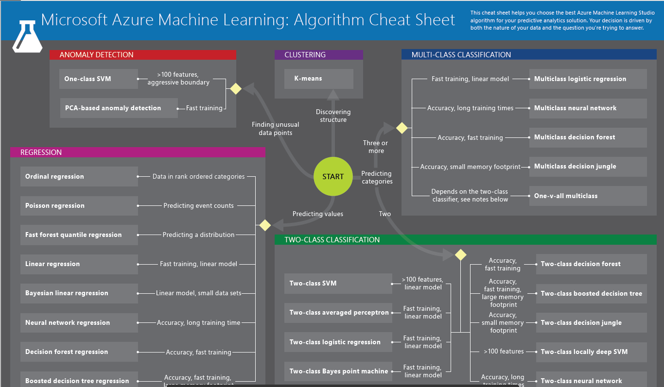

# **Support Vector Machine (SVM):**

This Model is used to create an anomaly detection model. This module is particularly useful in scenarios where you have a lot of "normal" data and not many cases of the anomalies you are trying to detect.

*Example*:  If you need to detect fraudulent transactions, you might not have many examples of fraud that you could use to train a typical classification model, but you might have many examples of good transactions.

There are basically 2 types of SVM:

1. **One-Class Support Vector Model**
2. **Two-Class Support Vector Model**

Support vector machines (SVMs) are supervised learning models that analyze data and recognize patterns. It infers the properties of normal cases and from these properties can predict which examples are unlike the normal examples.

The dataset which we use for training can contain all or mostly normal cases. We can apply different metrics to identify potential anomalies.

Example: We might use a large dataset of good transactions to identify cases that possibly represent fraudulent transactions.

**Disadvantage**:

|  |
| --- |
| The **One-Class Support Vector Model** module is not very scalable. If training time is limited, or we have too much data, then we should use other methods for anomaly detectors, such as [**PCA-Based Anomaly Detection**](https://docs.microsoft.com/en-us/azure/machine-learning/studio-module-reference/pca-based-anomaly-detection). |

**Model using Azure Machine Learning Studio:**

To demonstrate Support Vector Model we are using an example of “Anomaly Detection: Credit Risk”.

**Description**

The purpose of this experiment is to demonstrate how to use Azure ML anomaly detectors for anomaly detection. Anomaly detection is the process of detecting outliers in the data. Typical examples of anomaly detection tasks are detecting credit card fraud, medical problems or errors in text. Anomalies are also referred to as outliers, novelties, noise, deviations and exceptions. The data consists of 'normal' applications and 'risky' applications. Risky transactions are assumed to be anomalous and dissimilar from the training data.

The most notable difference compared to supervised classification is that the training data consists of only a single category or class corresponding to normal data. Any labels present in the data are ignored during training. This is in contrast with supervised training where data from both positive and negative classes will be used. The scores generated by the anomaly detectors indicate a measure of distance from the 'normal' category of data. The threshold for detection can be chosen by inspecting the ROC curve in the evaluate module.

**Dataset used:**

Input we are using:



Training data consists of credit card applications. The dataset consists of 1000 entries with 20 feature columns and 1 label column. The features are a mix of numeric and categorical types. In order to train the anomaly detectors we will be relying only on the 'normal' category (label value = 1) while ignoring the 'risky' category (label value = 2). However, we will be using both categories for evaluating the detector.

**Dataset Snippet:**

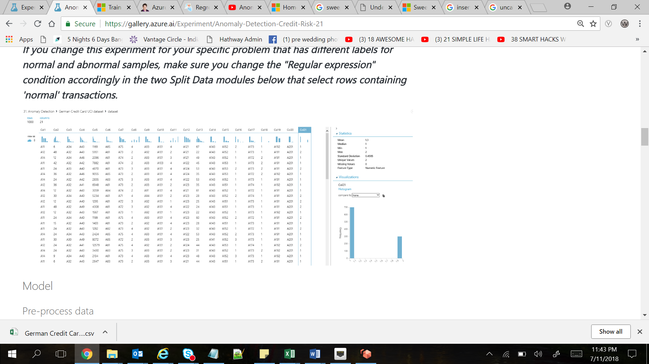

**Experiment:**

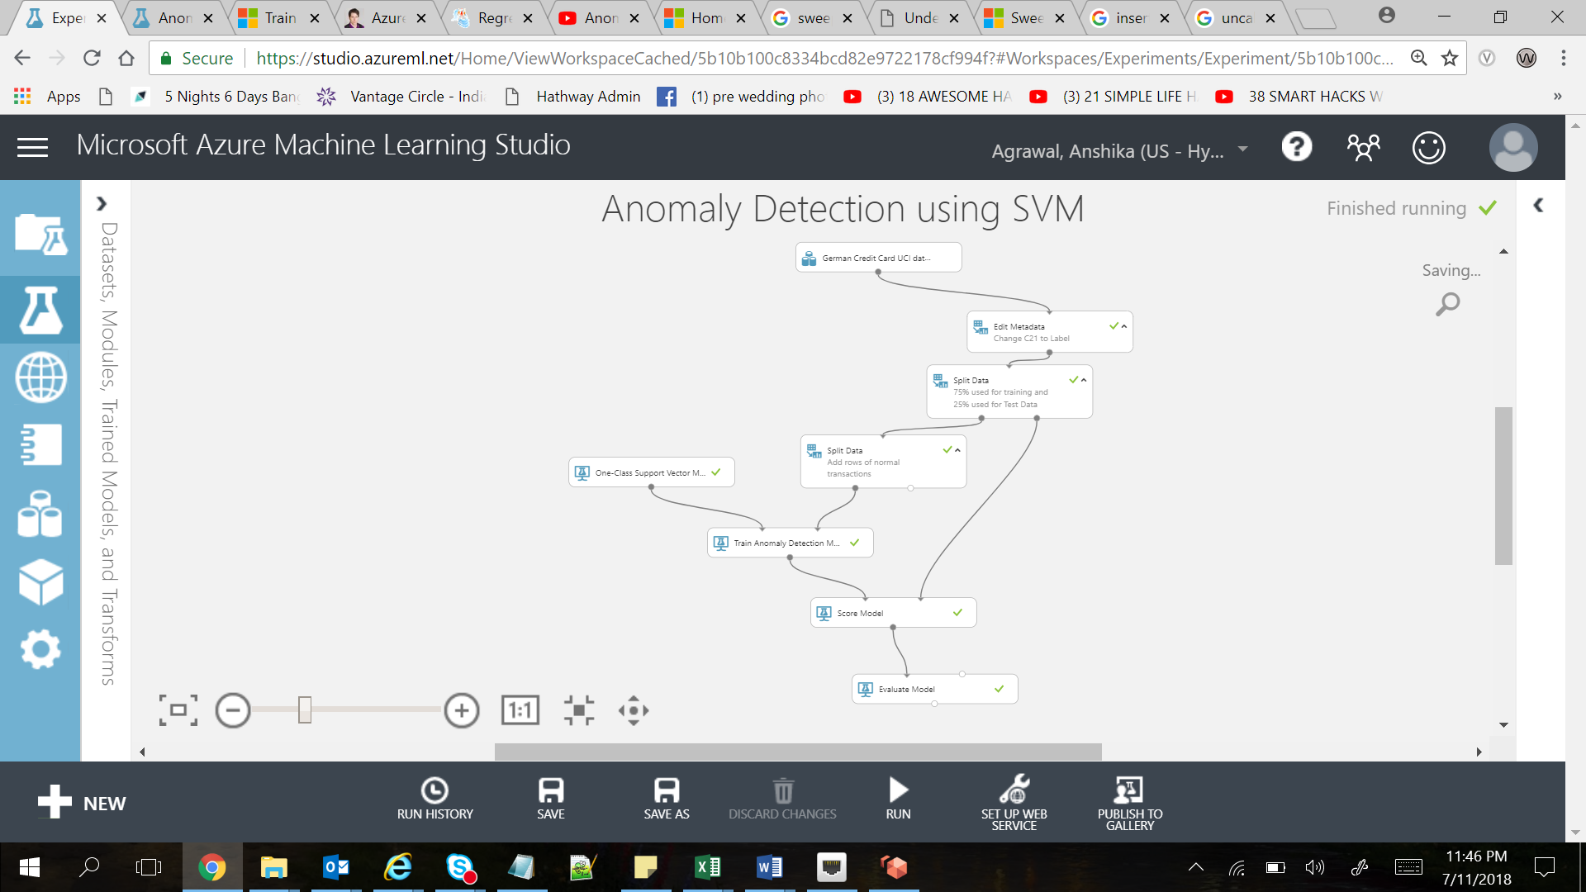

**One-Class Support Vector Machine**: One class support vector machine implements a binary classifier where the training data consists of examples of only one class (normal data). The model attempts to separate the collection of training data from the origin using maximum margin. By default, a radial basis kernel is used.

**Results:**

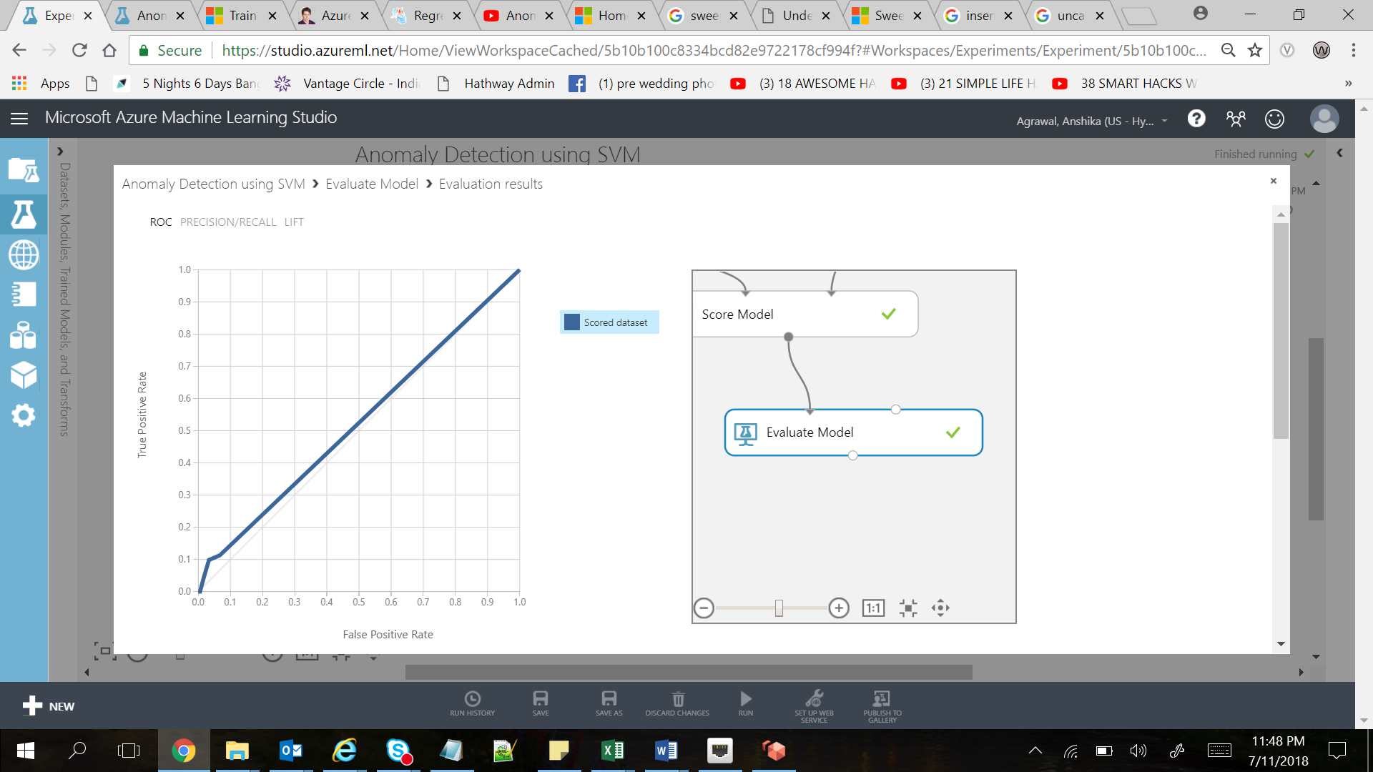

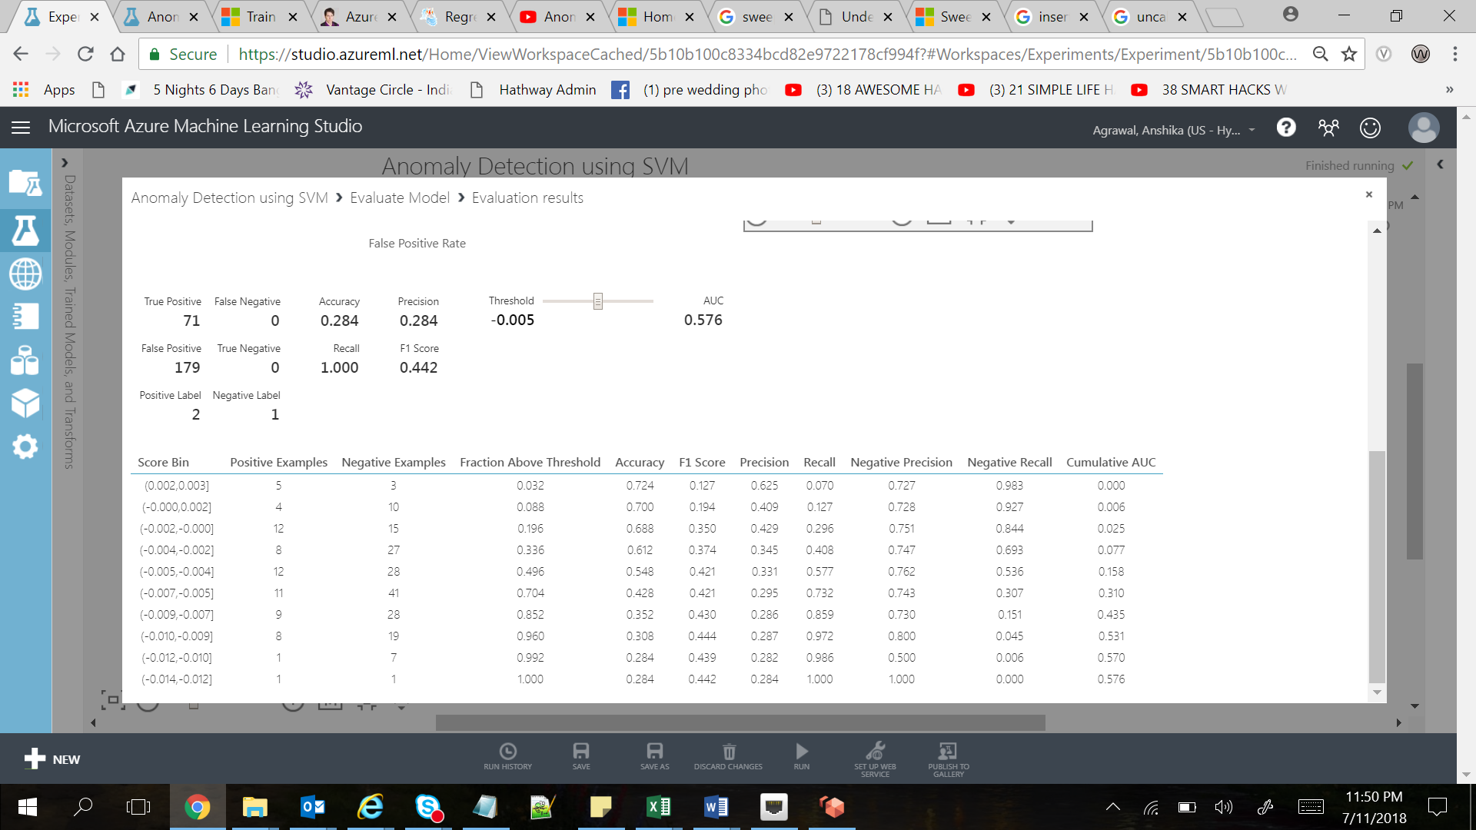

# **Two-Class Bayes Point Machine**

Naïve Bayes algorithm is specially used for text classification, which involves high dimensional training datasets. This algorithm is specially known for its simplicity and effectiveness. It can build model fast and make quick predictions.

The Naïve Bayes algorithm is called “naïve” because it makes the assumption that the occurrence of a certain feature is independent of the occurrence of other feature.

**Two-Class Bayes Point Machine** module in Azure Machine Learning Studio is used to create an untrained binary classification model.



**Model using Azure Machine Learning Studio:**

To demonstrate Two-Class Bayes Point Machine, we are using an example of “Bike Buyers Prediction”.

**Description**

The purpose of this experiment is to demonstrate how to use Azure ML anomaly detectors for classification in which one feature is independent of another. This algorithm uses the features which is independent of another and do the predictions.

*Example*: If we say that we need to find out a fruit which have orange color, sphere shaped and are sweet in taste. Features can decide, that it’s an orange fruit. So without any other dependency and only with the classifications it can judge the results and we use this algorithms especially when we have cases for classifications.

**Dataset used:**

Input we are using:



Training data consists of Bike Buyers Date. The dataset consists of 998 entries with 13 feature columns. The features are a mix of numeric and string types. We are using 75% data for training and 25% for test the data.

**Dataset Snippet:**

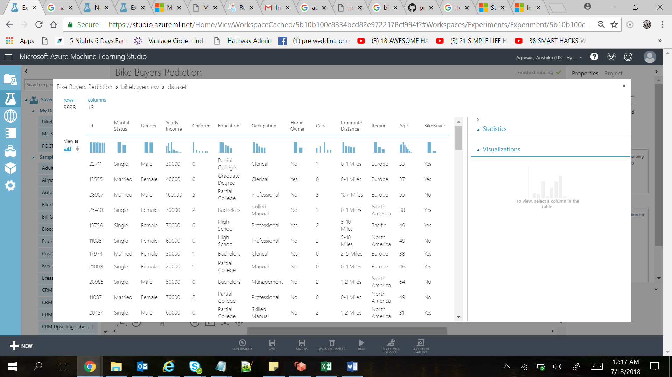

**Experiment:**

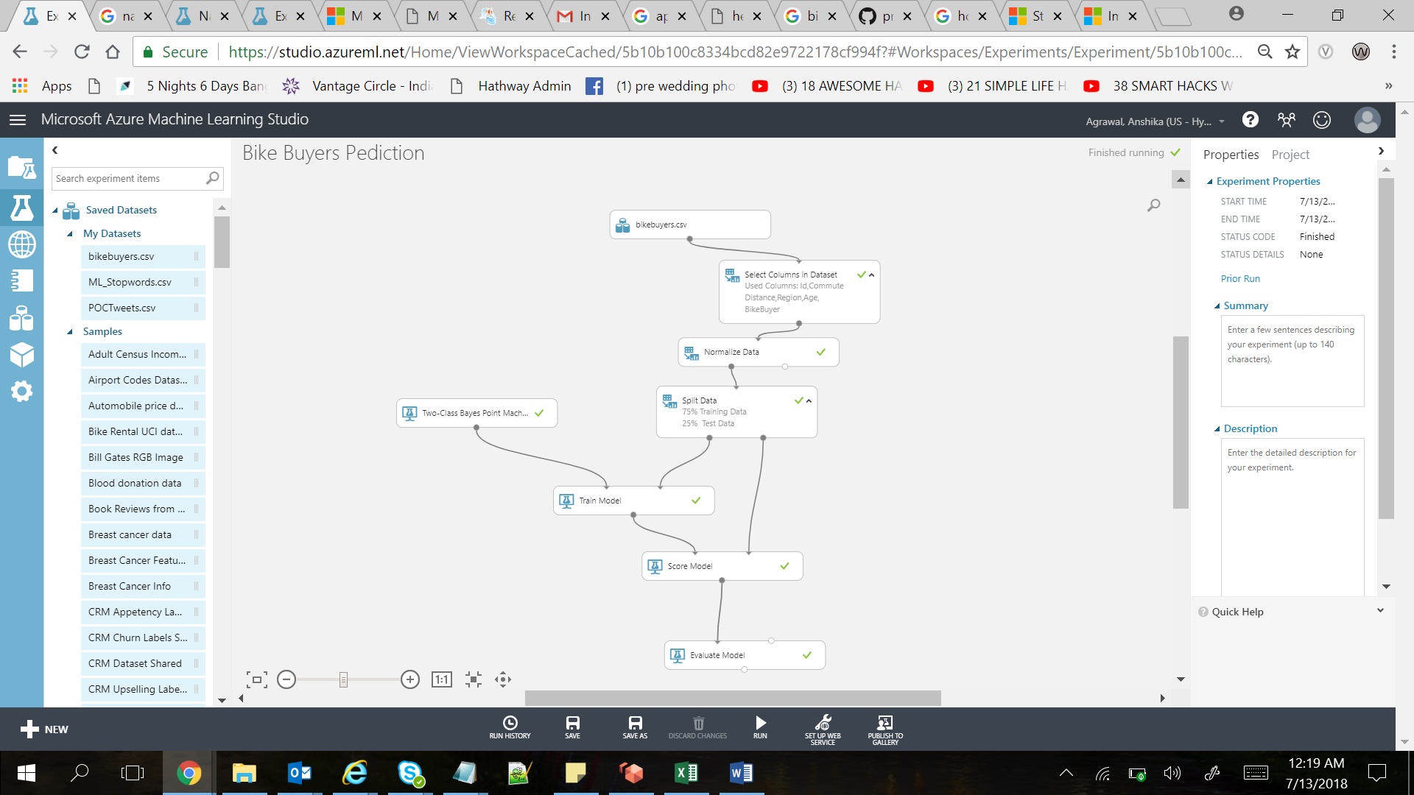

**Results:**

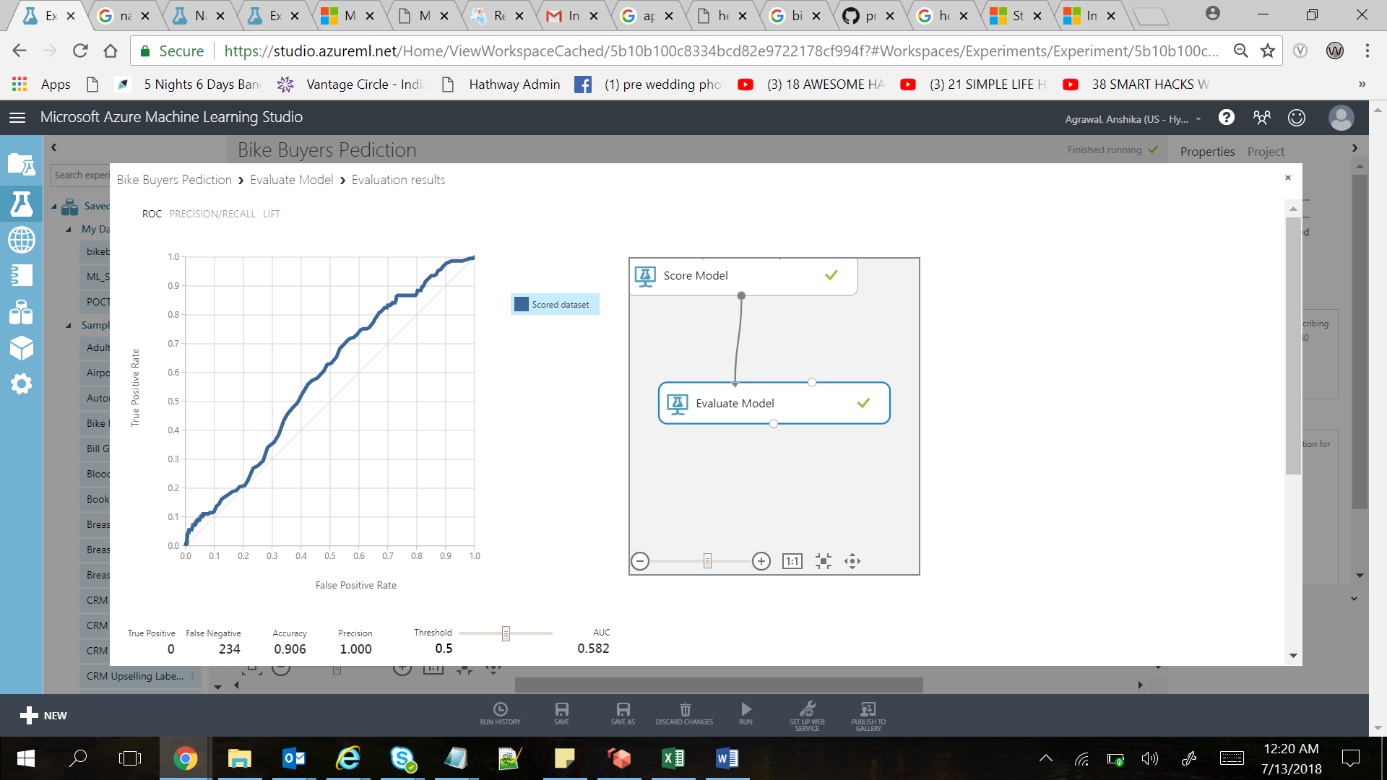

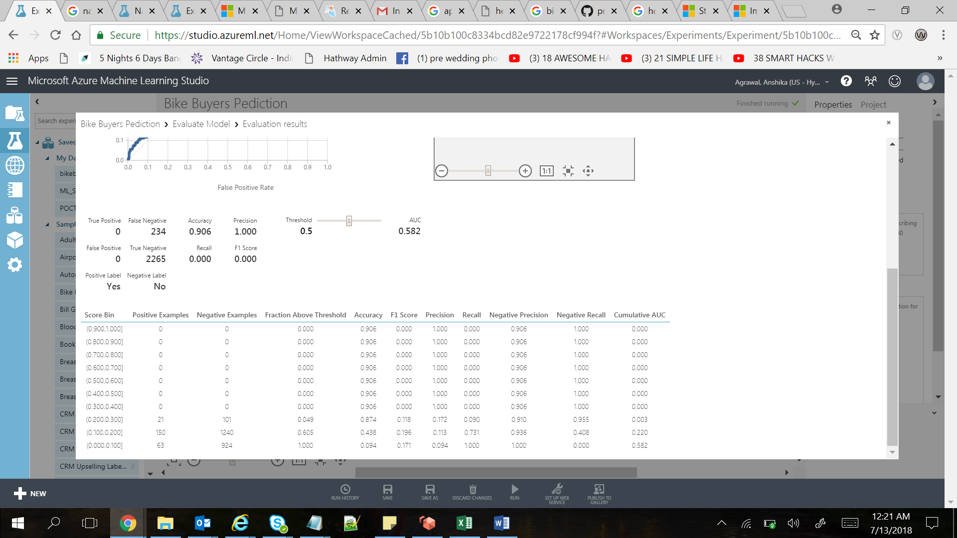

# **Polynomial Regression**

Azure Machine Learning doesn’t support Polynomial Regression natively but we can achieve this by applying SQL Transformation and use linear regression algorithms.

**Dataset used:**

Let’s try to achieve this by using our own data set having two points.

Very small data set:  20 points.  Two columns:  X & Y.  Column X goes from 1 to 20.  Column Y is a formula:  *=SIN(3.5*(A2-1)/20*2*PI())+A2/2*.  So basically, I add a sinusoid to a linear formula.  This gives the following data set:



If you plot that in Excel:

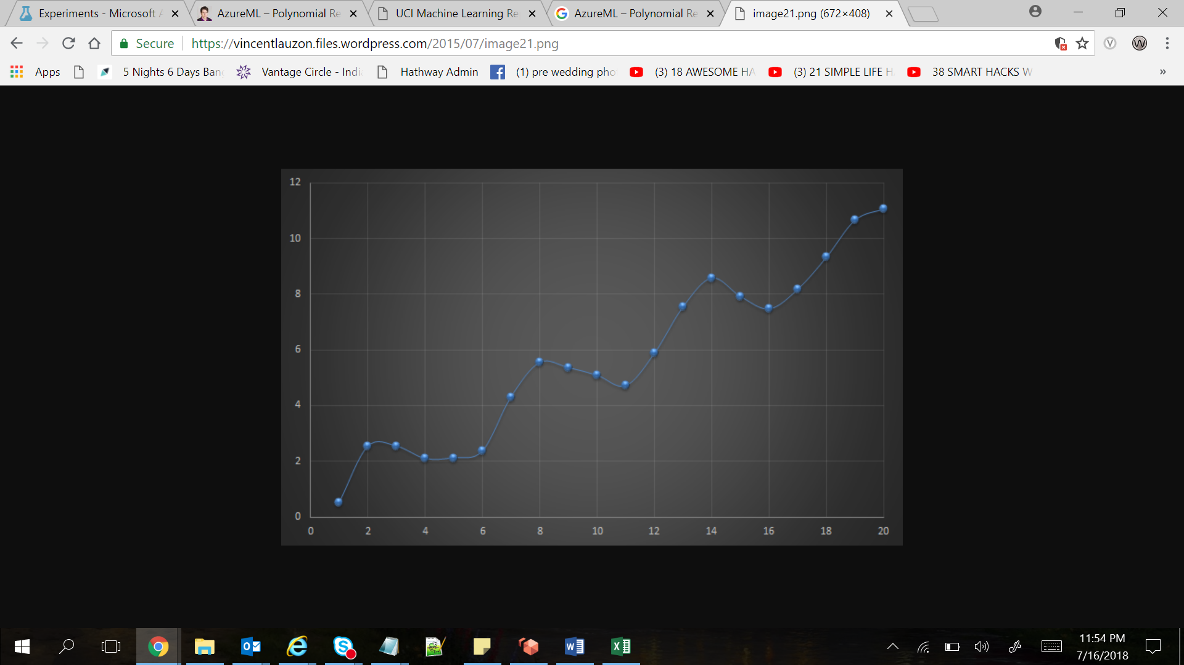

***From Polynomial to Linear:***

Azure Machine Learning doesn’t support polynomial regression. Polynomial regression is polynomial only in terms of the observed data, not the parameters.  A polynomial regression, in one dimension, is

f(x) = a_0 + a_1*x + a_2*x^2 + a_3*x^3 + … + a_n*x^n

which looks like a linear regression with n dimensions in input and one in output.  The input vector would be (x, x^2, …, x^n).  The regression becomes:

f(x) = a_0 + (a_1, a_2, …, a_n) * (x, x^2, …, x^n)

where the multiplication here is a scalar multiplication between two vectors.  Therefore we are back to a linear regression!

The trick is simply to augment the data set for it to contain the square, cube, etc.  of the observed (independent) variable.

***Apply SQL Transformation:***

Apply SQL Transformation has three entry points but only one is mandatory.

If you select the module you’ll see it takes an SQL expression in parameter:

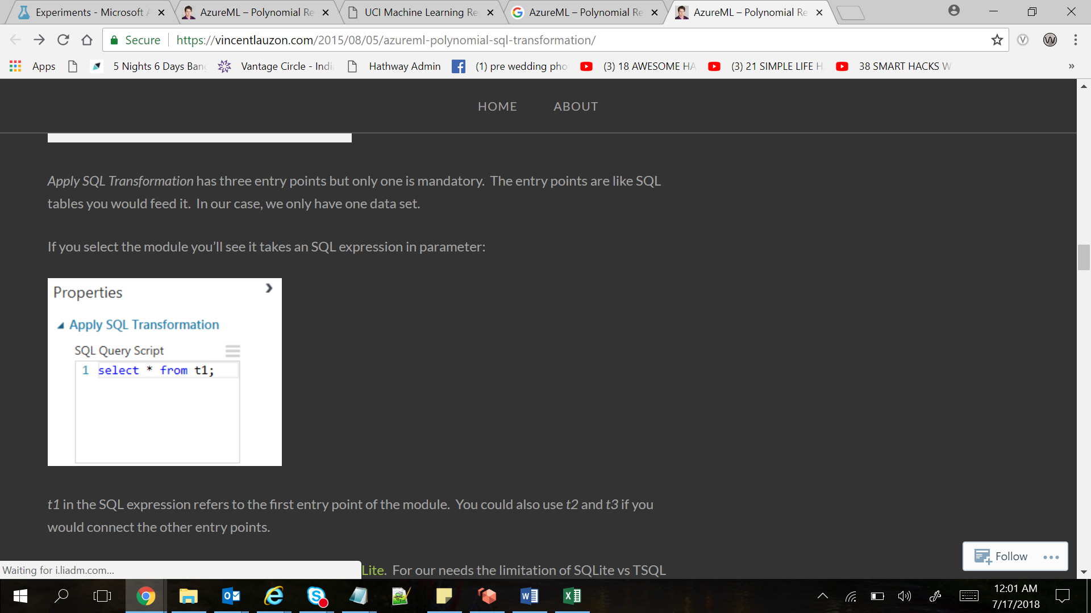

We will input this SQL:

*SELECT*  
*X,*  
*X*X AS X2,*  
*Y*  
*FROM t1*

*t1* in the SQL expression refers to the first entry point of the module.  We could also use *t2* and *t3* if we would connect the other entry points.

*Basically we can do a typical SQL projection using the SQL syntax.  This is quite powerful and can easily replace*Project Columns*and*Metadata Editor*Modules in one go.*

**Experiment:**

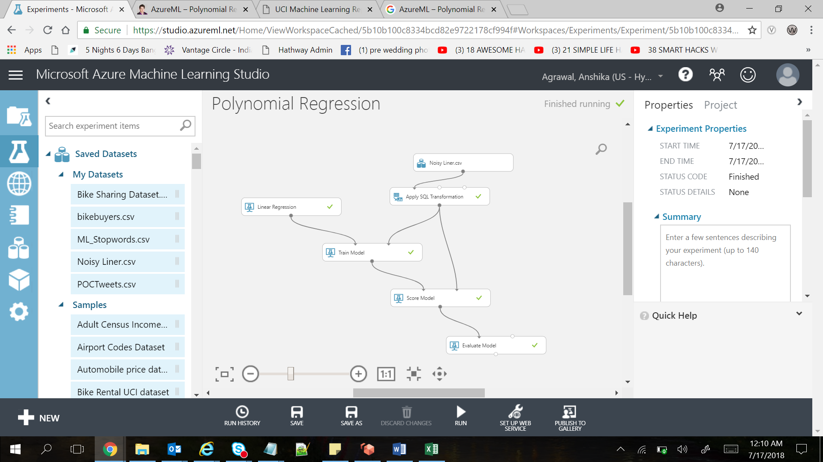

**Results:**

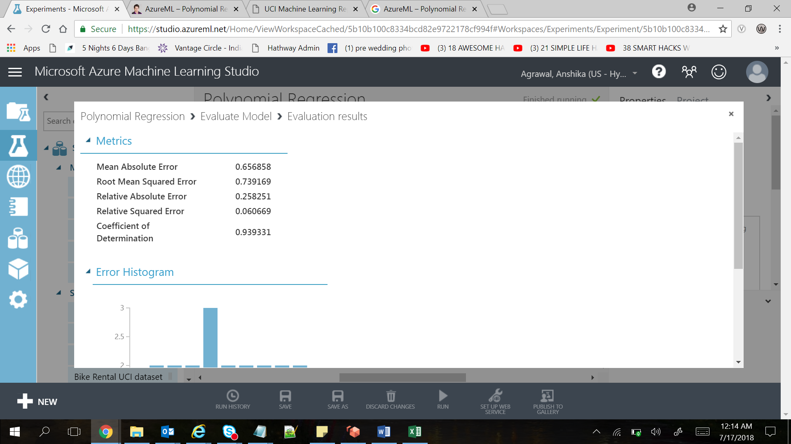

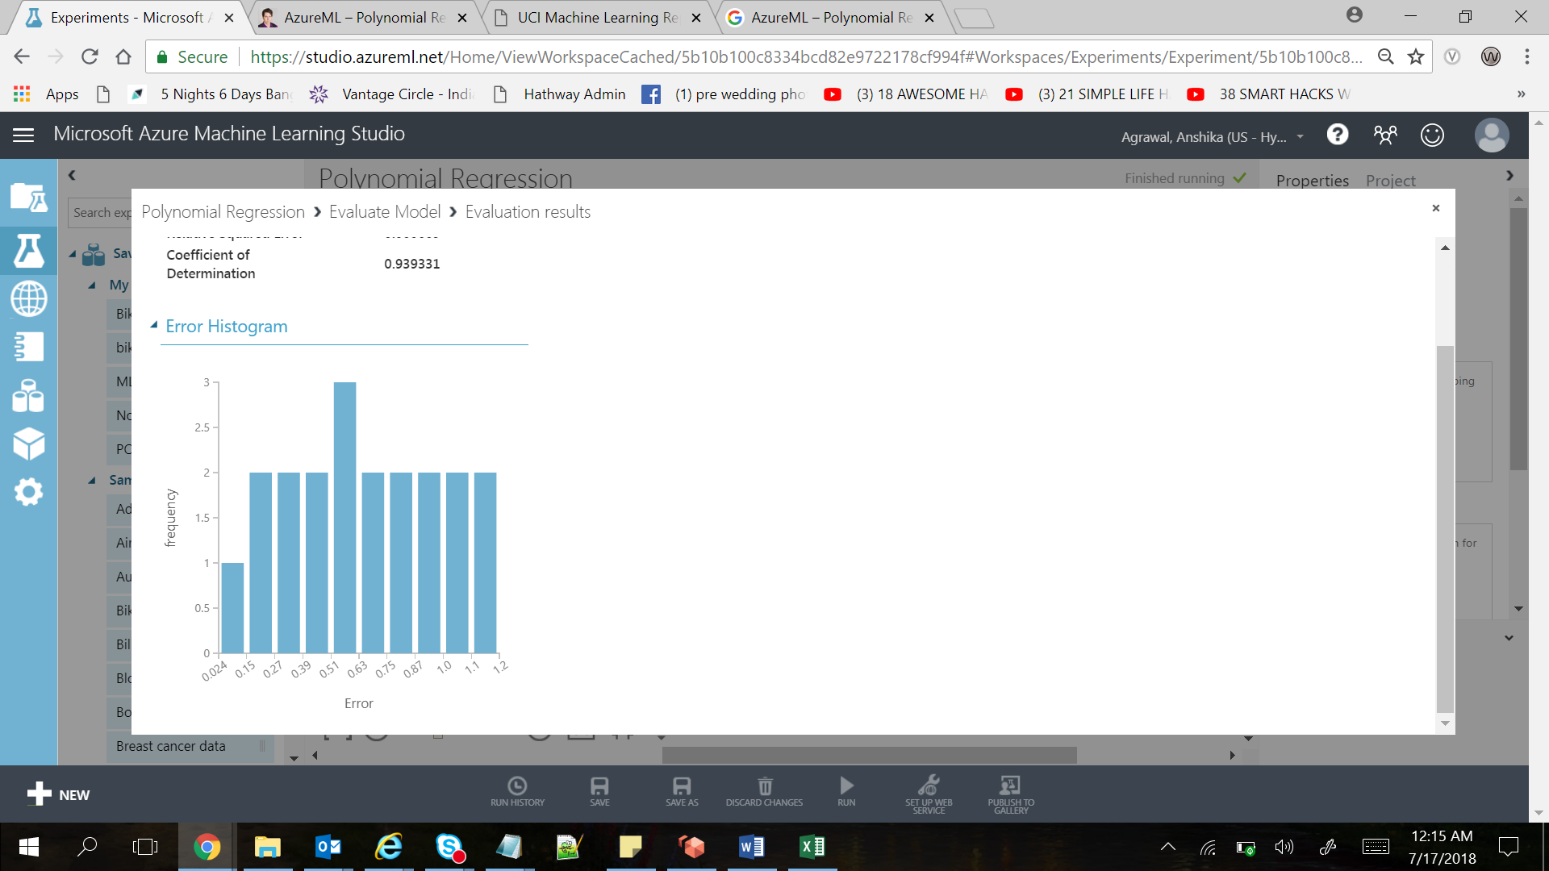

### *Summary*

It is possible to implement a Polynomial Regression using *Linear Regression* and *Apply SQL Transformation* modules.

The latter module is quite powerful and can replace both *Project Columns* and *Metadata Editor* modules.

# **Boosted Decision Regression Tree**

 Boosting means that each tree is dependent on prior trees. The algorithm learns by fitting the residual of the trees that preceded it. Thus, boosting in a decision tree ensemble tends to improve accuracy with some small risk of less coverage. This regression method is a supervised learning method, and therefore requires a labeled dataset. The label column must contain numerical values.

Experiment:-

This experiment demonstrates the **feature engineering** process for building a **regression** model using bike rental demand prediction .

**Input Dataset :**



**Experiment Snapshot:-**

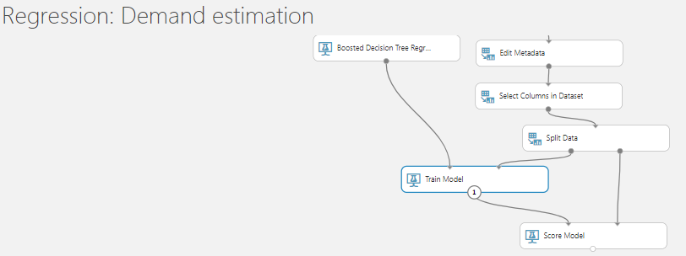

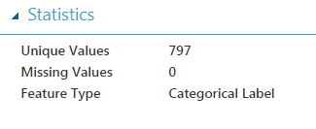

**Output from score module**

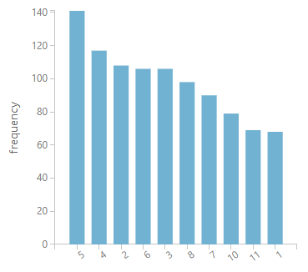

**Summary:-**

For this experiment, because the goal was to predict a number (the demand for the bikes, represented as the number of bike rentals) we chose a regression model. Moreover, because the number of features is relatively small (less than 100) and these features are not sparse, the decision boundary is very likely to be nonlinear.

Based on these factors, we used the **Boosted Decision Tree Regression** module, a commonly used nonlinear algorithm, to build the models.

# **Logistic Regression**

Logistic regression is a well-known method in statistics that is used to predict the probability of an outcome, and is particularly popular for classification tasks. The algorithm predicts the probability of occurrence of an event by fitting data to a logistic function.

**Experiment:-**

We used the Iris data set, a well-known benchmark dataset for multiclass classification from the [UCI repository](https://archive.ics.uci.edu/ml/datasets/Iris). We use the **Multiclass Logistic Regression** module to perform multiclass classification.

**Input Data:-**



**Experiment Snapshot:-**

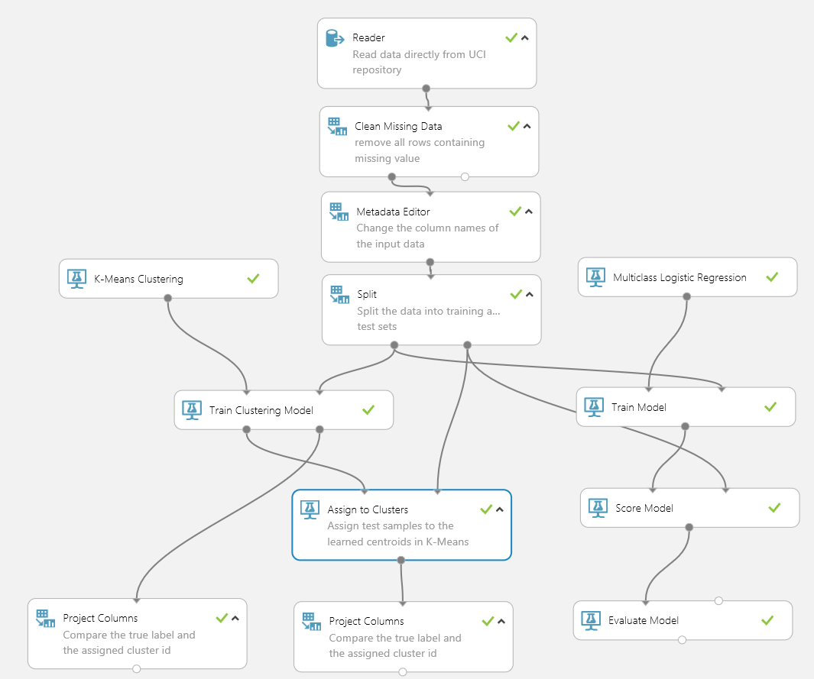

**Results**

When the **Train Clustering Model** module and **Assign to Clusters** module output the clustering assignment results, the original data is also returned, including all features and the label column. To simplify these results, we use **Project Columns** to extract just the two columns, Label and Assignments, for both the training and test datasets. The column Label (which we renamed using **Metadata Editor**) contains the true labels and the column Assignments contains the predicted clustering label.

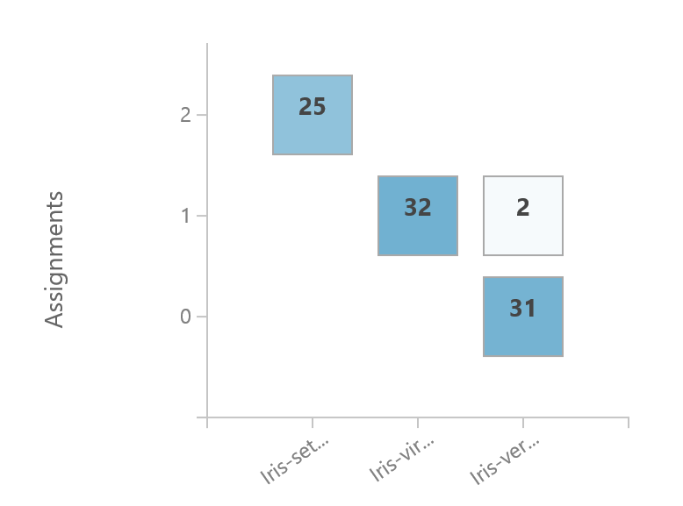

In this plot, the values for Label are on the x-axis, and the predicted clustering labels in Assignments are on the y-axis. The cluster label 0 corresponds to Iris-versicolor, the cluster label 1 to Iris-virginica, and cluster label 2 to Iris-setosaWe can get the similar plot for the test data set (below), and get similar observations.

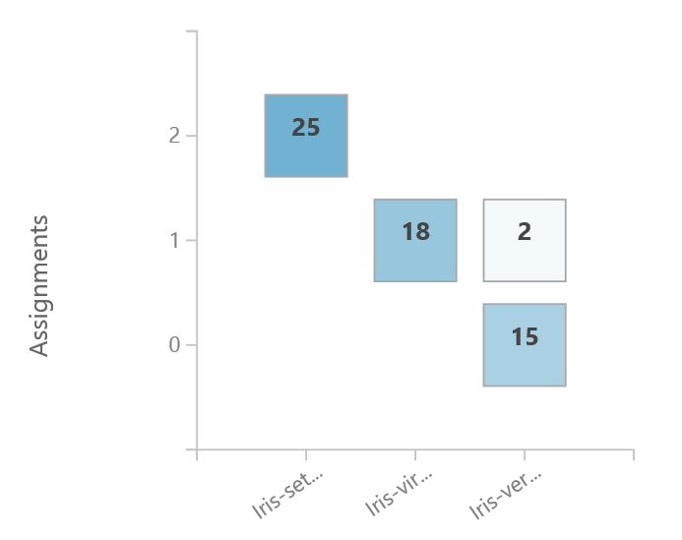

For the **Multiclass Logistic Regression** module, you can view the output by clicking the output port of the **Evaluate Model** module and selecting **Visualize**. You can view several metrics including overall accuracy, average accuracy, micro and macro-averaged precision and recall. A confusion matrix is also provided.

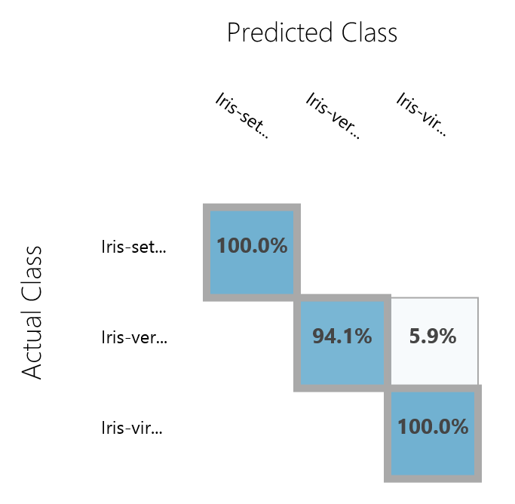

To evaluate clustering results we classify each example according to the majority of labels in its cluster. We observe from confusion matrix that our clustering is very accurate since only cluster 1 has examples from two different classes. Moreover multiclass accuracy of our unsupervised clustering is 96.67%, which is very close to the multiclass accuracy 98.33% obtained by supervised multiclass logistic regression.

# **Two-Class Boosted Decision Tree**

A boosted decision tree is an ensemble learning method in which the second tree corrects for the errors of the first tree, the third tree corrects for the errors of the first and second trees, and so forth. Predictions are based on the entire ensemble of trees together that makes the prediction.

**Experiment:-**

In this experiment, we predict whether scheduled passenger flight is delayed or not using a Binary-classifier.

**Input Data:-**



**Pre-process data**

A dataset usually requires some pre-processing before it can be analyzed.

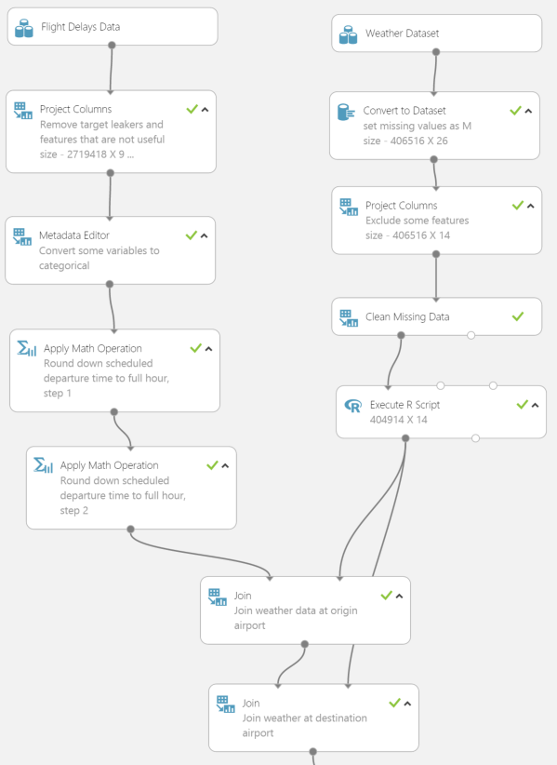

**Results**

The boosted decision tree model has AUC of 0.697 on the validation set.

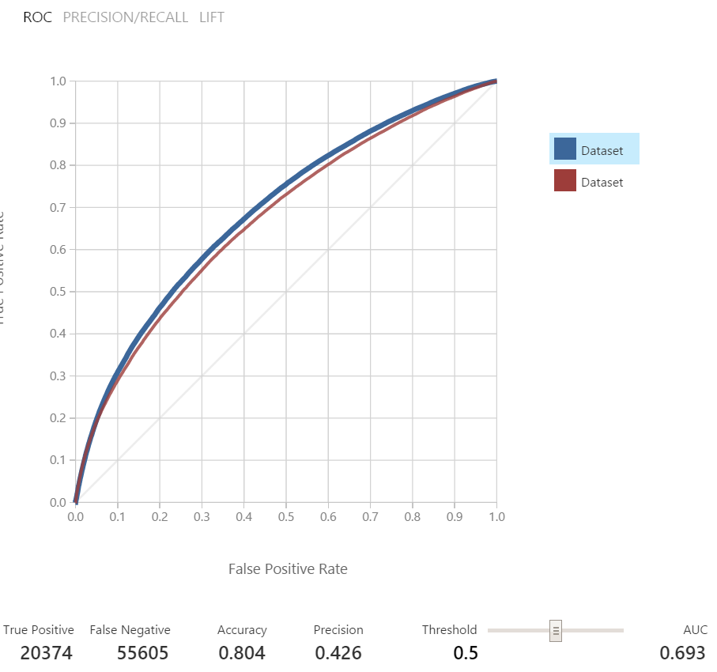

**Post-Processing**

To make the results easier to analyze, we used the airportID field to join the dataset that contains the airport names and location

# **Simple Linear Regression**

The linear regression is a method that defines the relationship between two data and defines uncertain relationships between two variables.

y = a.x +b – This equation defines a linear regression,

where **y** is a dependent variable, **x** is an independent variable, and **b** is a constant.

Linear regression equation tries to predict the approximate relationship between the dependent and independent variables.

**Example: -**

Our dataset contains height and weight of individuals and we will be predicting the weight of an individual.

**Steps: -**

1. Prepare the dataset.
2. Select the relevant columns from the dataset.
3. Split the dataset into training and testing dataset.
4. Train the model using training dataset.
5. Apply linear regression on top of training dataset.
6. Use Score model to check the scored label (weight in this case).

Below screenshot shows the steps used in the azure machine learning predictive experiment.

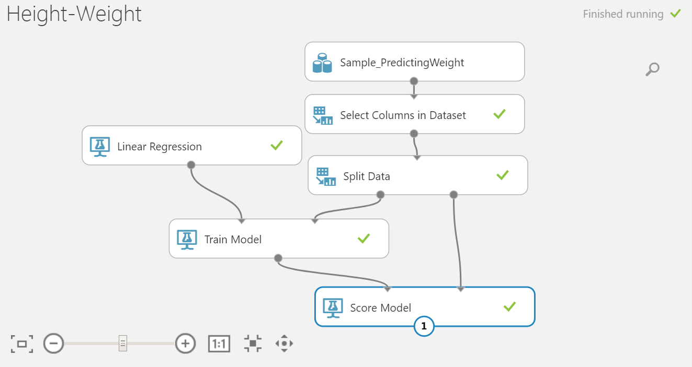

Below is “Sample_PredictingWeight “dataset used in the experiment.



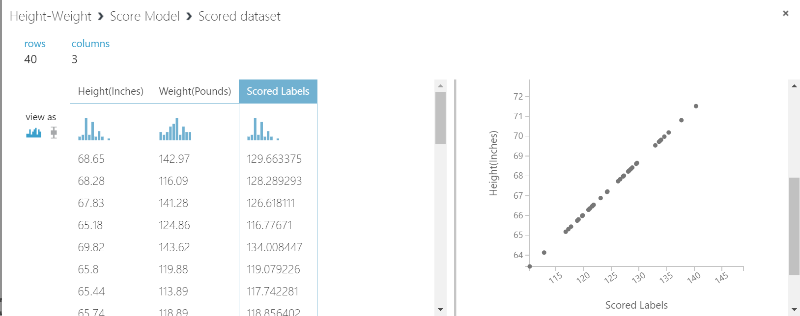

# **Multiclass Neural Network**

A neural network is a set of interconnected layers. The inputs are the first layer, and are connected to an output layer by an acyclic graph comprised of weighted edges and nodes.

Between the input and output layers you can insert multiple hidden layers. Most predictive tasks can be accomplished easily with only one or a few hidden layers. However, recent research has shown that deep neural networks (DNN) with many layers can be very effective in complex tasks such as image or speech recognition. The successive layers are used to model increasing levels of semantic depth.

The relationship between inputs and outputs is learned from training the neural network on the input data. The direction of the graph proceeds from the inputs through the hidden layer and to the output layer. All nodes in a layer are connected by the weighted edges to nodes in the next layer.

To compute the output of the network for a particular input, a value is calculated at each node in the hidden layers and in the output layer. The value is set by calculating the weighted sum of the values of the nodes from the previous layer. An activation function is then applied to that weighted sum.

**Example:-**

**Multiclass Neural Network** module **will be used** to train models to recognize hand-written digits. We will use the [Net#](http://azure.microsoft.com/en-us/documentation/articles/machine-learning-azure-ml-netsharp-reference-guide) language to define network architecture.

**Input Dataset:-**



**Steps To Run the Experiment:**

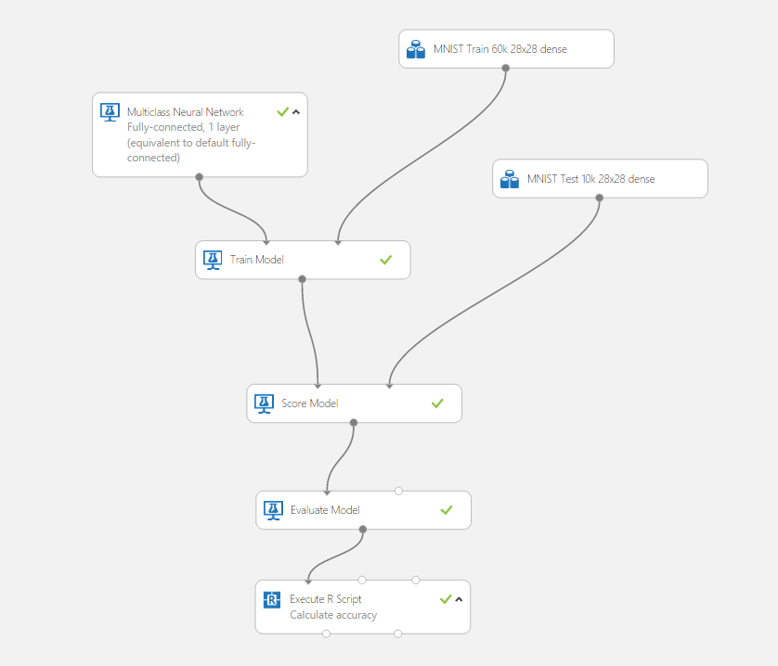

1. Run and after that right-click the **Result Dataset** port of the **Execute R script** module named Calculate accuracy, and select **Visualize**.
2. The chart shows you the accuracy of the model, which should be around **0.9767** (**97.67%**). Another way to interpret these results is that the model has an error of **2.33%**.   
   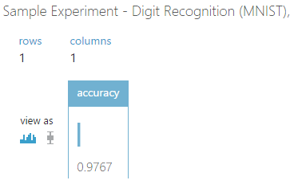
3. To view the confusion table for this model (shown in the following diagram), right-click the output of the **Evaluate Model** module and select **Visualize**.   
   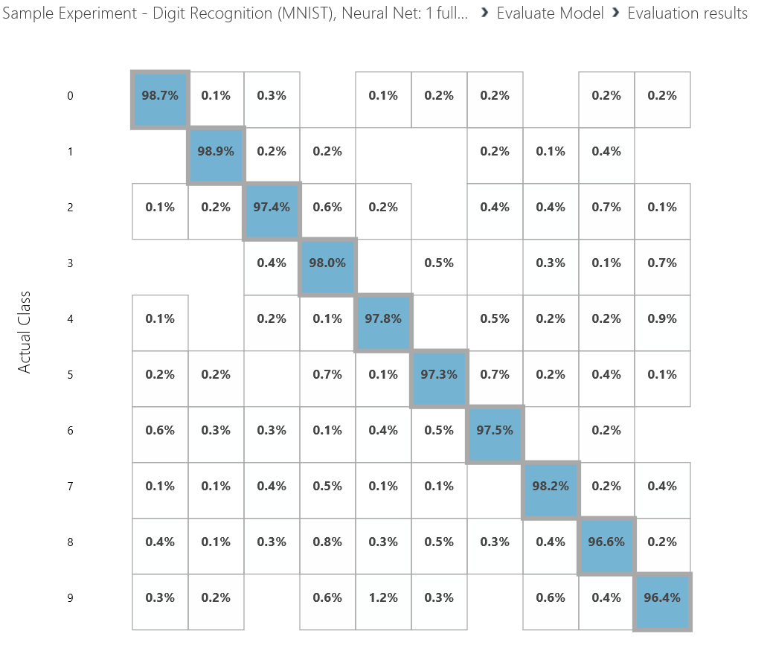
4. Click the **Multiclass Neural Network** module, and review the custom script that defines the neural network architecture. The lines of code in the **Neural network definition** text box are written using the Net# language.   
   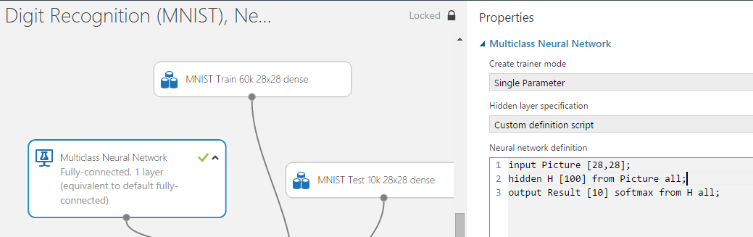

In the next line of Net# code, the input layer is connected to the hidden layer **H** which has 100 nodes.

Finally, the hidden layer is connected to the output layer **Result**. The output layer has a size of 10 because there are 10 digits to classify.

# **Multiclass Decision Forest**

The decision forest algorithm is an ensemble learning method for classification. The algorithm works by building multiple decision trees and then voting on the most popular output class. Voting is a form of aggregation, in which each tree in a classification decision forest outputs a non-normalized frequency histogram of labels. The aggregation process sums these histograms and normalizes the result to get the “probabilities” for each label. The trees that have high prediction confidence have a greater weight in the final decision of the ensemble.

**Example:-**

Qualitative Activity Recognition of Weight Lifting Exercises. Classifier to predict if exercise has been done correctly.

**Input Data:-**



**Steps:-**

**Step 1: Getting the data**

We first use the **Reader module** to obtain the data.

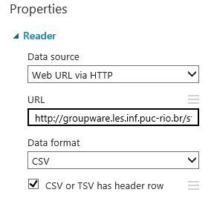

**Step 2: Clean missing data**

We will only use those columns that have no missing values. All the other columns will removed in the **Clean missing** module.

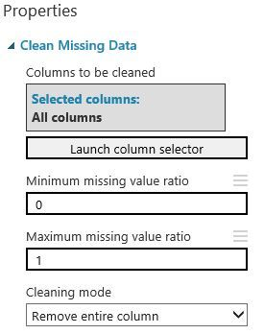

**Step 3: Select required columns**

We only need information about the sensors from the belt, forearm, arm, and dumbell sensors. The first columns are about the test person and the time frames, which we won’t need, so we exclude them with the **Project columns** module.

[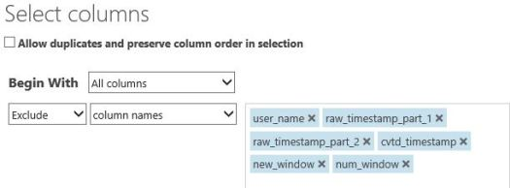](https://i0.wp.com/www.md2c.nl/wp-content/uploads/2015/03/Select-columns-Azure-ML.jpg)

**Step 4: Remove highy correlated columns (optional)**

In this experiment, we will test several models. For one of them, we will remove the highly correlated columns. We use the findCorrelation() function from the caret package. This package is not installed by default. In order to use this package, please download and zip the package, upload it to Azure, drag it on the canvas, and then you can install it using the **Execute R** module.

# Map 1-based optional input ports to variables  
wle <- maml.mapInputPort(1) # class: data.frame

# install caret package  
install.packages(“src/caret_6.0-41.zip”,lib=”.”,repos=NULL,verbose=TRUE)  
library(caret, lib.loc=”.”,verbose=TRUE)

last <- as.numeric(ncol(wle))  
prior <- last – 1

# set variables to numerics, except the “classe”  
for (i in 1:prior) {  
wle[,i] <- as.numeric(wle[,i])  
}

# find the highly correlated variables  
highly.cor <- findCorrelation(cor(wle[, -c(last)]), cutoff=0.9)

# remove highly correlated variables  
wle <- wle[, -highly.cor]

# Select data.frame to be sent to the output Dataset port  
maml.mapOutputPort(“wle”);

**Step 5: Split the dataset into a training and a test set**

We **split** the dataset into 70% for training, and 30% for testing. We set the seed to make this experiment reproducible.  In this case, we didn’t use the stratified split, as it didn’t improve the results. However, be aware that sometimes a normal split is not good enough.

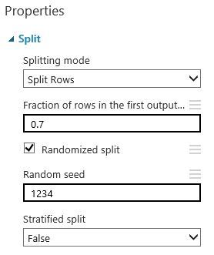

**Step 6: Train the models**

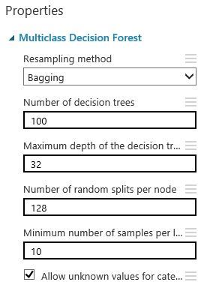

**Step 7: Score the test data**

With the **Score model** module, the 30% testing data will be scored with the trained model.

**Step 8: Evaluate the models**

With the Evaluate model module, we are able to evaluate the model. First, we get the overall results.

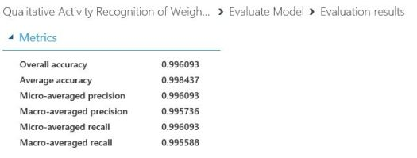

Secondly, we get the confusion matrix, showing the results per class.

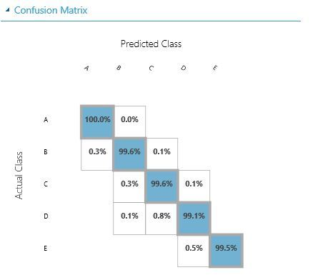

# **Multiclass Decision Jungle**

[Decision jungles](http://go.microsoft.com/fwlink/?LinkId=403675) are a recent extension to [decision forests](http://go.microsoft.com/fwlink/?LinkId=403677). A decision jungle consists of an ensemble of decision directed acyclic graphs (DAGs).

Decision jungles have the following advantages:

* By allowing tree branches to merge, a decision DAG typically has a lower memory footprint and a better generalization performance than a decision tree, albeit at the cost of a somewhat higher training time.
* Decision jungles are non-parametric models, which can represent non-linear decision boundaries.
* They perform integrated feature selection and classification and are resilient in the presence of noisy features.

**Example:-**

This experiment explains how to build a **Human Activity Classifier** with Azure Machine Learning. This classifier predicts somebody’s activity class based on the use of wearable sensors.

**Input Dataset:-**



**Description of the Human Activity Classifier**

This classifier predicts somebody’s activity class (sitting, standing up, standing, sitting down, walking). It is based on the **Human Activity Recognition** dataset. Human Activity Recognition (HAR) is an active research area, results of which have the potential to benefit the development of assistive technologies in order to support care of the elderly, the chronically ill and people with special needs. Activity recognition can be used to provide information about patients’ routines to support the development of e-health systems. Two approaches are commonly used for HAR: image processing and use of wearable sensors. In this case we will use information generated by wearable sensors (Ugulino et al, 2012).

* user (text)
* gender (text)
* age (integer)
* how_tall_in_meters (real)
* weight (int)
* body_mass_index (real)
* x1 (type int, contains the read value of the axis ‘x’ of the 1st accelerometer, mounted on waist)
* y1 (type int, contains the read value of the axis ‘y’ of the 1st accelerometer, mounted on waist)
* z1 (type int, contains the read value of the axis ‘z’ of the 1st accelerometer, mounted on waist)
* x2 (type int, contains the read value of the axis ‘x’ of the 2nd accelerometer, mounted on the left thigh)
* y2 (type int, contains the read value of the axis ‘y’ of the 2nd accelerometer, mounted on the left thigh)
* z2 (type int, contains the read value of the axis ‘z’ of the 2nd accelerometer, mounted on the left thigh)
* x3 (type int, contains the read value of the axis ‘x’ of the 3rd accelerometer, mounted on the right ankle)
* y3 (type int, contains the read value of the axis ‘y’ of the 3rd accelerometer, mounted on the right ankle)
* z3 (type int, contains the read value of the axis ‘z’ of the 3rd accelerometer, mounted on the right ankle)
* x4 (type int, contains the read value of the axis ‘x’ of the 4th accelerometer, mounted on the right upper-arm)
* y4 (type int, contains the read value of the axis ‘y’ of the 4th accelerometer, mounted on the right upper-arm)
* z4 (type int, contains the read value of the axis ‘z’ of the 4th accelerometer, mounted on the right upper-arm)

The following diagram shows the entire experiment (as the experiment is too big to fit on the screen, it would be better to download the sample and view it in Azure ML studio):

[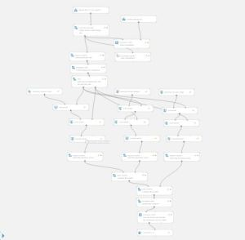](https://i2.wp.com/www.md2c.nl/wp-content/uploads/2015/02/Azure-machine-learning-full-model.jpg)

First, we take care of possible missing data using the module **Clean Missing Data,**deleting all rows with missing data if required. Although this dataset doesn’t have missing data, it is recommendable to check your incoming data when you create a webservice out of your model.

We added an instance of the **Descriptive Statistics** module to produce some basic statistics. Besides we checked the inter-item correlation (excluding gender and class as they are categorical) using the **Execute R** option.

[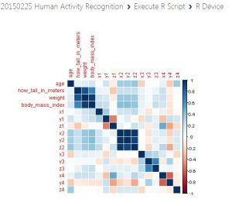](https://i1.wp.com/www.md2c.nl/wp-content/uploads/2015/02/Azure-machine-learning-correlation-visualization.jpg)

We will exclude body_mass_index using the **Project Columns** module. Here we also exclude user. Thereafter, we use the **Metadata Editor** module specify gender to be a categorical variable.

We split the dataset in a training (70%) and a test (30%) set.

To find the best-fitting model, we will test 3 different models.

**Multiclass Decision Forest model settings**

[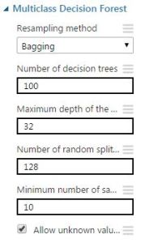](https://i0.wp.com/www.md2c.nl/wp-content/uploads/2015/02/multiclass-decision-forest-settings-azure-machine-learning.jpg)

**Multiclass Neural Network model settings**

[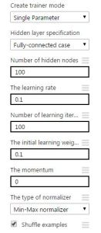](https://i2.wp.com/www.md2c.nl/wp-content/uploads/2015/02/multiclass-neural-network-settings-azure-machine-learning.jpg)

**Multiclass Decision Jungle model settings**

[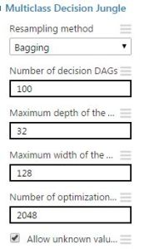](https://i1.wp.com/www.md2c.nl/wp-content/uploads/2015/02/multiclass-decision-jungle-settings-azure-machine-learning.jpg)

|  |  |  |  |
| --- | --- | --- | --- |
| **Measures** | **Model 1** | **Model 2** | **Model 3** |
| Overall accuracy | 0.9943 | 0.9738 | 0.9851 |
| Average accuracy | 0.9977 | 0.9895 | 0.9940 |
| Micro-averaged precision | 0.9943 | 0.9738 | 0.9851 |
| Macro-averaged precision | 0.9910 | 0.9645 | 0.9784 |
| Micro-averaged recall | 0.9943 | 0.9738 | 0.9851 |
| Macro-averaged recall | 0.9893 | 0.9610 | 0.9706 |

[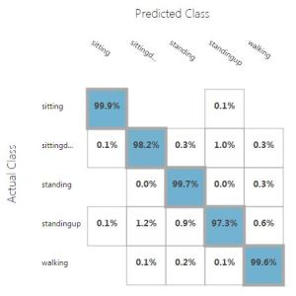](https://i2.wp.com/www.md2c.nl/wp-content/uploads/2015/02/multiclass-decision-forest-results-azure-machine-learning.jpg)

Multiclass Decision Forest results[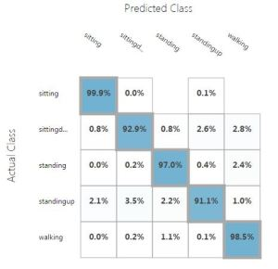](https://i1.wp.com/www.md2c.nl/wp-content/uploads/2015/02/multiclass-neural-network-results-azure-machine-learning.jpg)

Multiclass Neural Network results[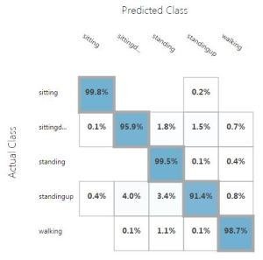](https://i2.wp.com/www.md2c.nl/wp-content/uploads/2015/02/multiclass-decision-jungle-results-azure-machine-learning.jpg)

# **One-vs-All Multiclass**

This module implements the one vs. all method, in which a binary model is created for each of the multiple output classes. Each of these binary models for the individual classes is assessed against its complement (all other classes in the model) as though it were a binary classification issue. Prediction is then performed by running these binary classifiers, and choosing the prediction with the highest confidence score.

In essence, an ensemble of individual models is created and the results are then merged, to create a single model that predicts all classes. Thus, any binary classifier can be used as the basis for a one-vs-all model.

**Example:-**

Sample experiment that uses multiclass classification to predict the letter category as one of the 26 capital letters in the English alphabet.

**Input Data:-**



**Steps:-**

Multiclass Classification: Letter Recognition

This experiment demonstrates how to build a multiclass classification model for letter recognition, using Azure ML Studio.

Workflow

Below is a screenshot of the entire experiment in Azure ML

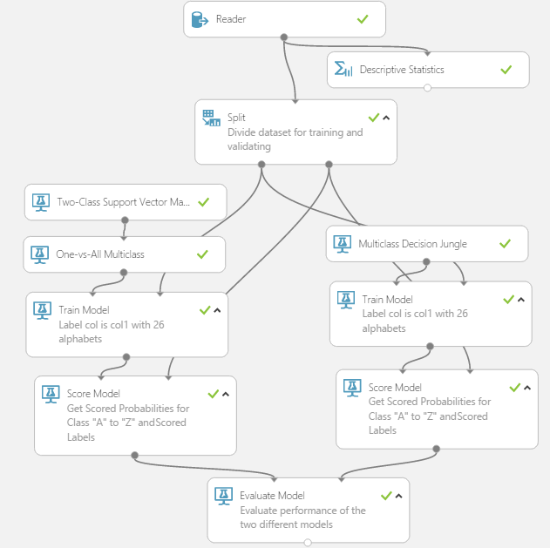

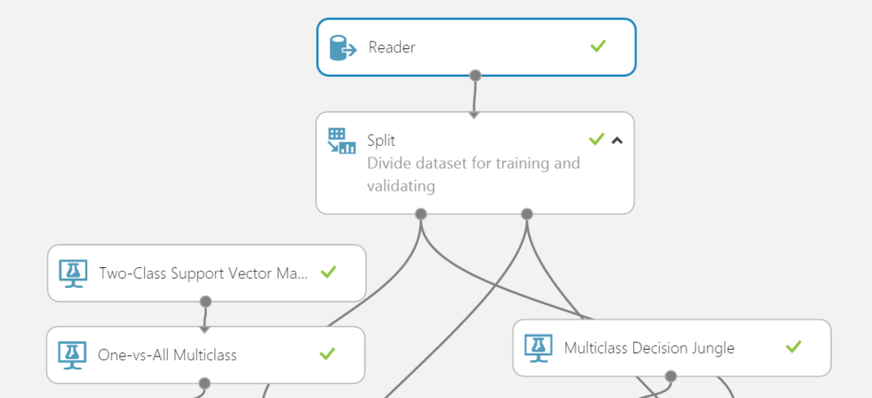

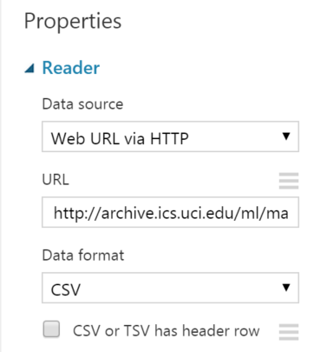

The uploaded data contains 20000 rows and 17 columns. Col1 contains the label, which indicates which of the 26 classes (the letters A-Z) is represented by the numerical attributes in columns 2-17.

**Define Features**

Some features are better for predicting the target than others. Also, some features have a strong correlation with other features, so they will not add much new information to the model and can be removed. When building a model we might use all the available features in the dataset, or we might use only a subset of the features. For this experiment, we will use all 16 columns (Col2-Col17) that contain features of the 20,000 characters.

**Train Model**

The next step is to train a model. First, split the data into training and testing sets. Select and drag the **Split** module to the experiment canvas and connect it to the second input port of the **Train Model** module. Set **Fraction of rows in the both output dataset** to 0.5. This way, we'll use 50% of the data to train the model, and the other 50% for testing.

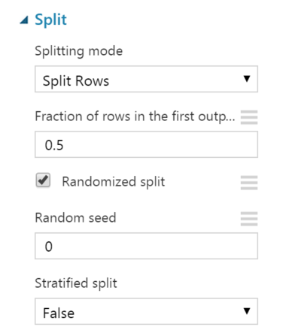

In this experiment we will use two different algorithms. Drag the following modules into the experiment workspace: **Multiclass Decision Jungle**, and the **Two-Class Support Vector Machines** module connected to the **One-vs-All Multiclass** module.

Connect the output of the algorithm module to the input ports of the **Train Model** module, along with the training data.

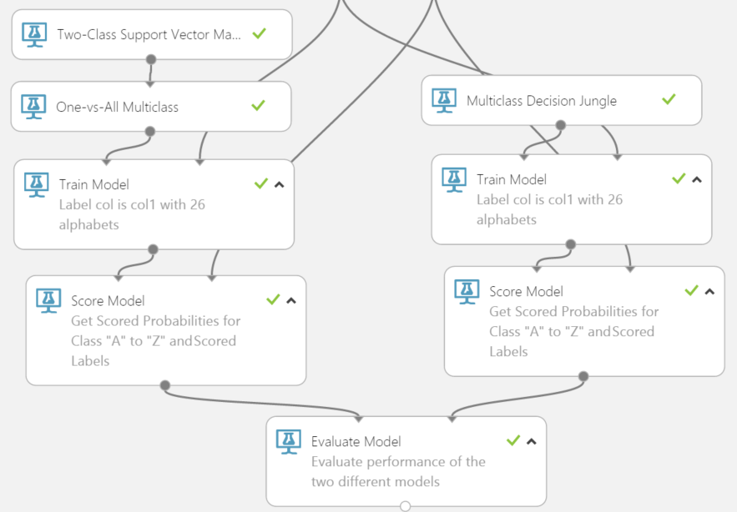

**Score and Evaluate the Model**

Now that we've trained the model, we can use it to score the other 50% of the data and see how well the model predicts and classifies new data.

Add the **Score Model** module to the experiment canvas, and connect the left input port to the output of the **Train Model** module. Connect the right input port to the test data output (right port) of the **Split**module.

Run the experiment and view the output of the **Score Model** module, by clicking the output port and selecting **Visualize\***. The output shows the the scored labels and the probabilities for each of the 26 classes ("A"-"Z").

Finally, to test the quality of the results, drag the **Evaluate Model** module to the experiment canvas, and connect the left input port to the output of the **Score Model** module. There are two input ports because the **Evaluate Model** module can be used to compare two models. Therefore, we can compare the performance of the two different algorithms that we applied -- **Multiclass Decision Jungle** and the **Two-Class Support Vector Machines** used together with the **One-vs-All Multiclass** modules.

Run the experiment and view the output of the **Evaluate Model** module, by clicking the output port and selecting **Visualize**. The following diagram shows the resulting statistics for the model.

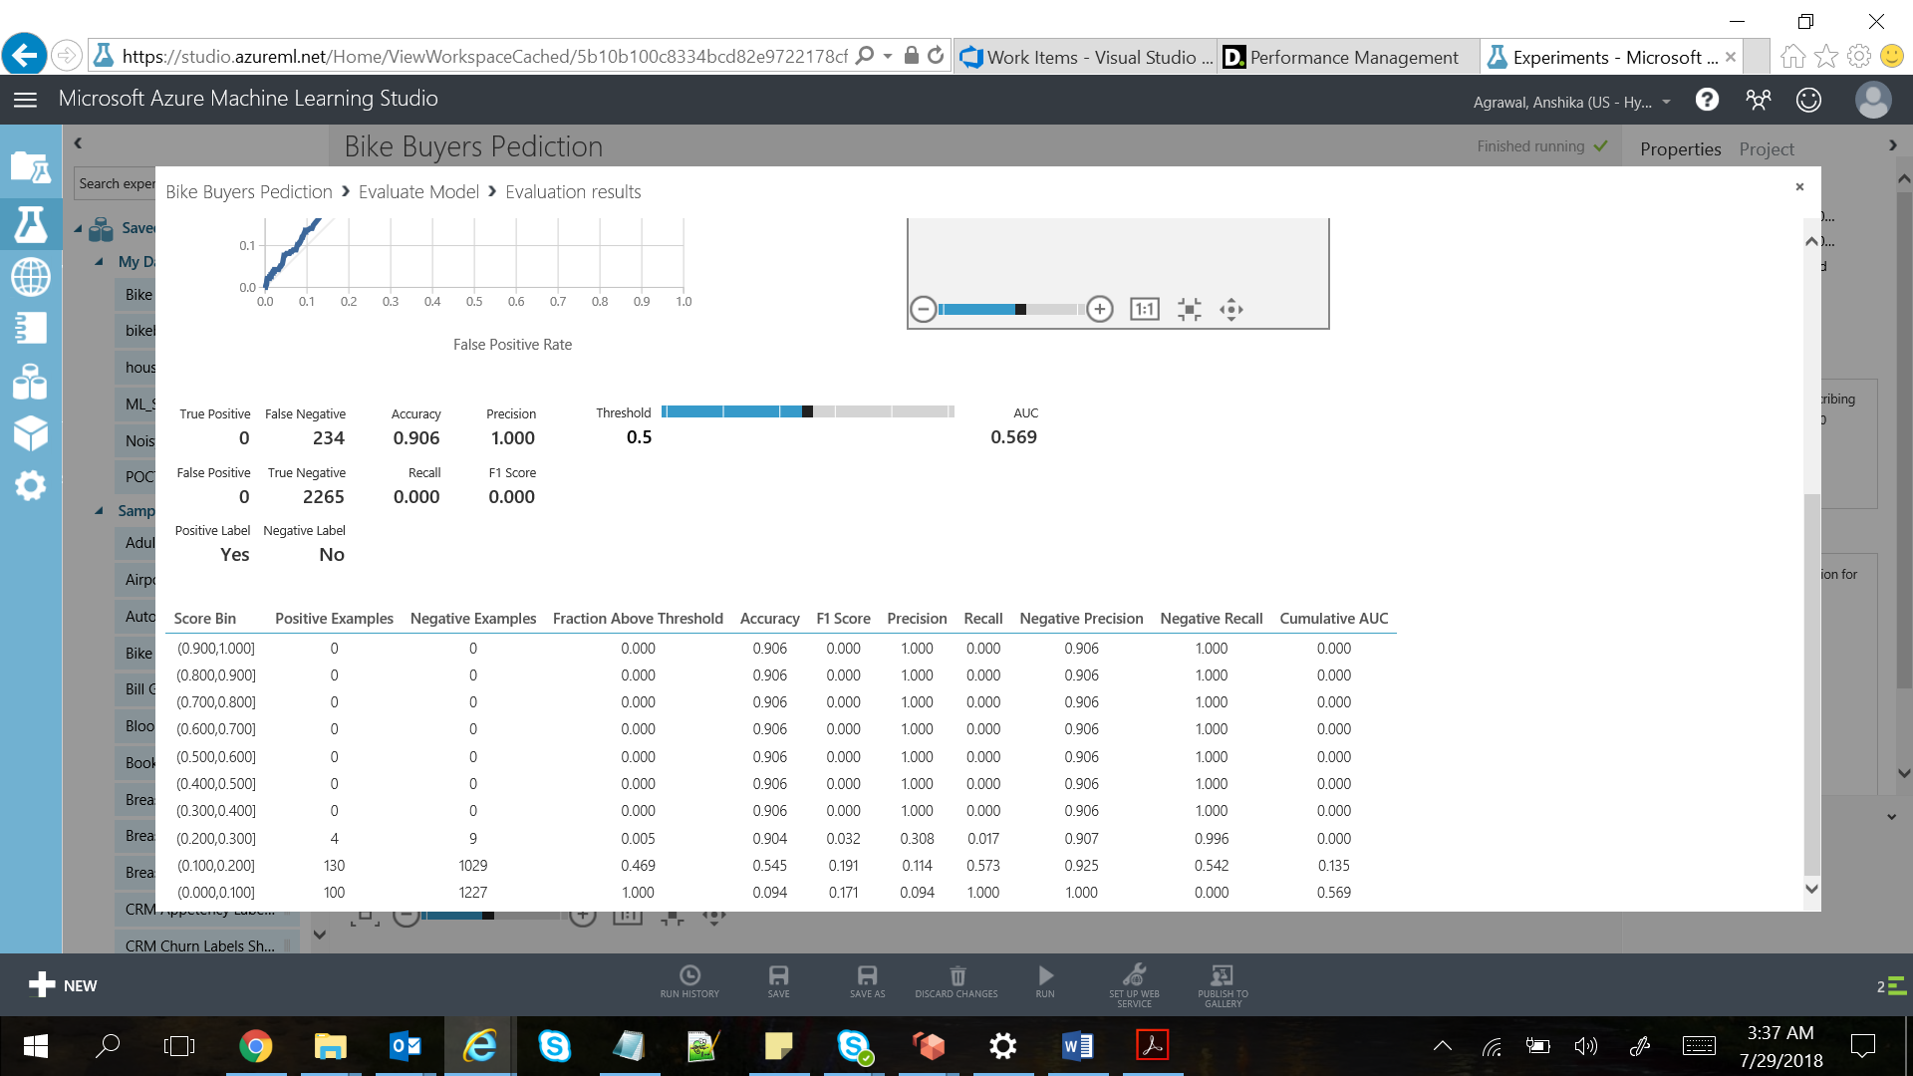

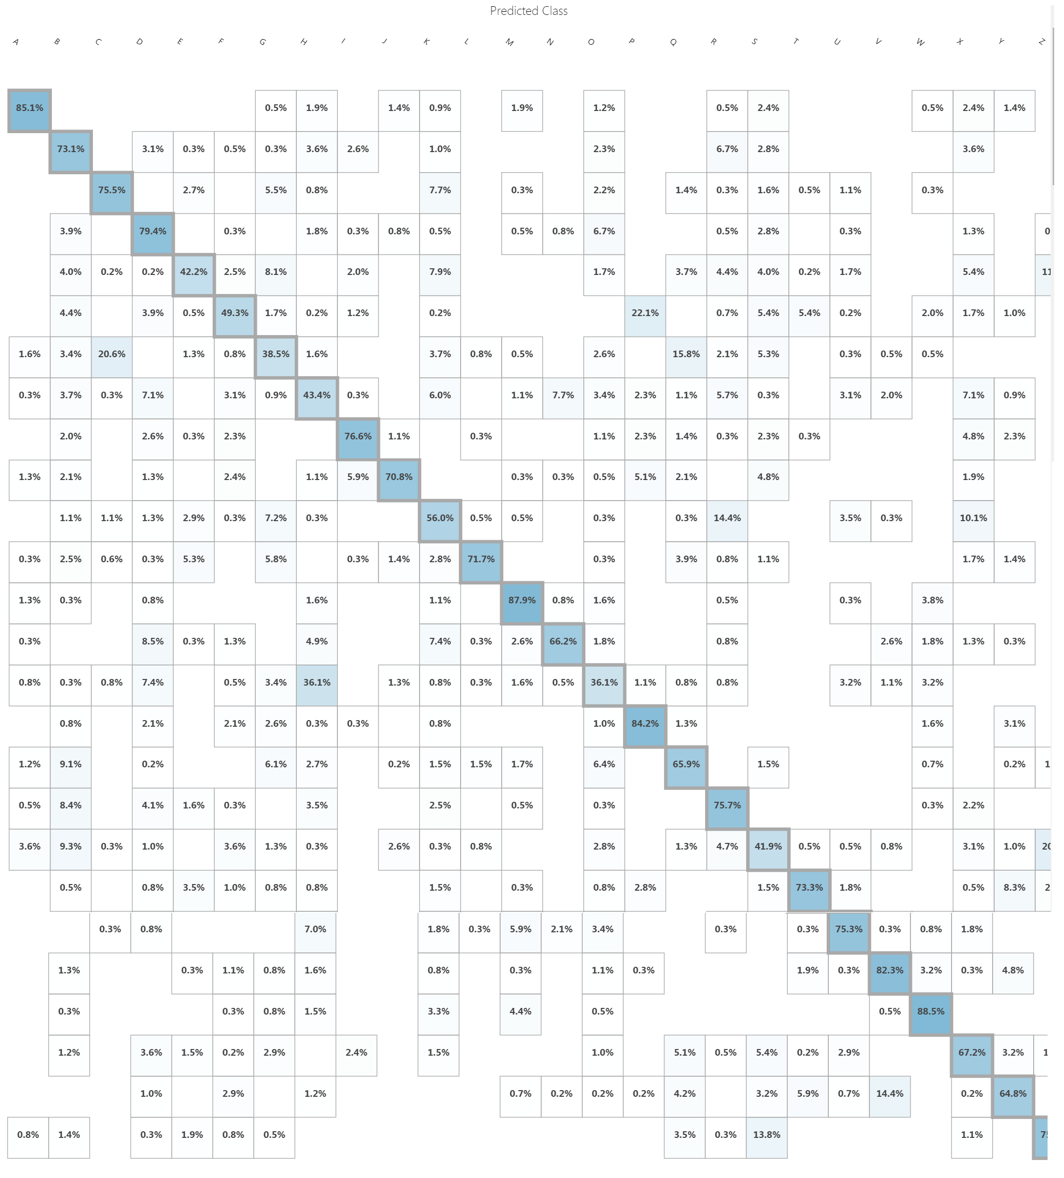

# **PCA-Based Anomaly Detection**

This Model is used to create an anomaly detection model using Principal Component Analysis.

This module helps build a model in scenarios where it is easy to obtain training data from one class, such as valid transactions, but difficult to obtain sufficient samples of the targeted anomalies.

*Example*:  To detect fraudulent transactions, very often we don't have enough examples of fraud to train on, but have many examples of good transactions. The **PCA-Based Anomaly Detection** module solves the problem by analyzing available features to determine what constitutes a "normal" class, and applying distance metrics to identify cases that represent anomalies. This let you train a model using existing imbalanced data.

*Principal Component Analysis*, which is frequently abbreviated to PCA, is an established technique in machine learning. PCA is frequently used in exploratory data analysis because it reveals the inner structure of the data and explains the variance in the data.

PCA works by analyzing data that contains multiple variables. It looks for correlations among the variables and determines the combination of values that best captures differences in outcomes. These combined feature values are used to create a more compact feature space called the *principal components*.

For anomaly detection, each new input is analyzed, and the anomaly detection algorithm computes its projection on the eigenvectors, together with a normalized reconstruction error. The normalized error is used as the anomaly score. The higher the error, the more anomalous the instance is.

**Advantage**:

|  |
| --- |
| If training time is limited, or we have too much data, then we should use other methods for anomaly detectors, such as [**PCA-Based Anomaly Detection**](https://docs.microsoft.com/en-us/azure/machine-learning/studio-module-reference/pca-based-anomaly-detection). |

**Model using Azure Machine Learning Studio:**

To demonstrate we are using an example of “Bike Buyers Prediction”.

**Dataset used:**

Input we are using:



**Dataset Snippet:**

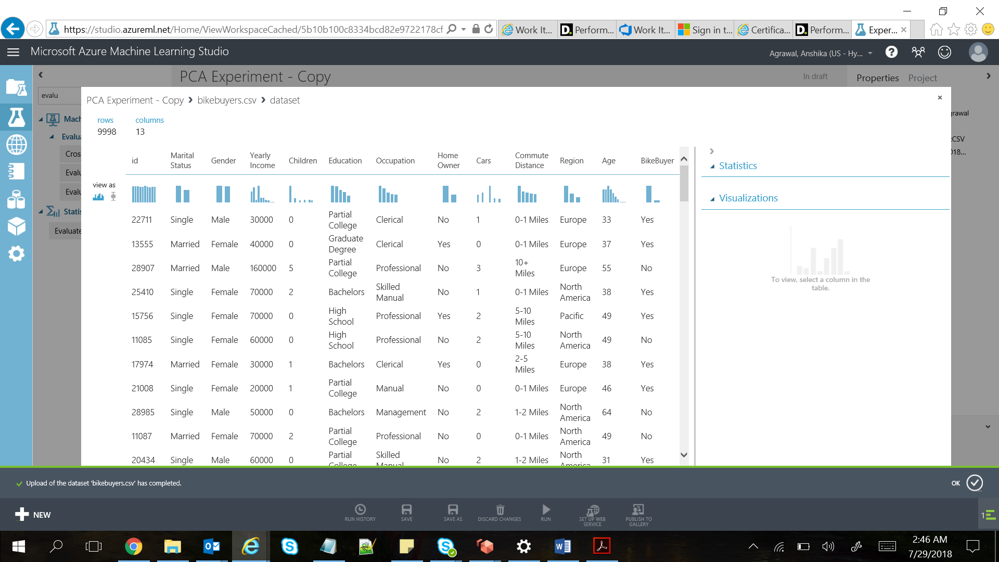

**Experiment:**

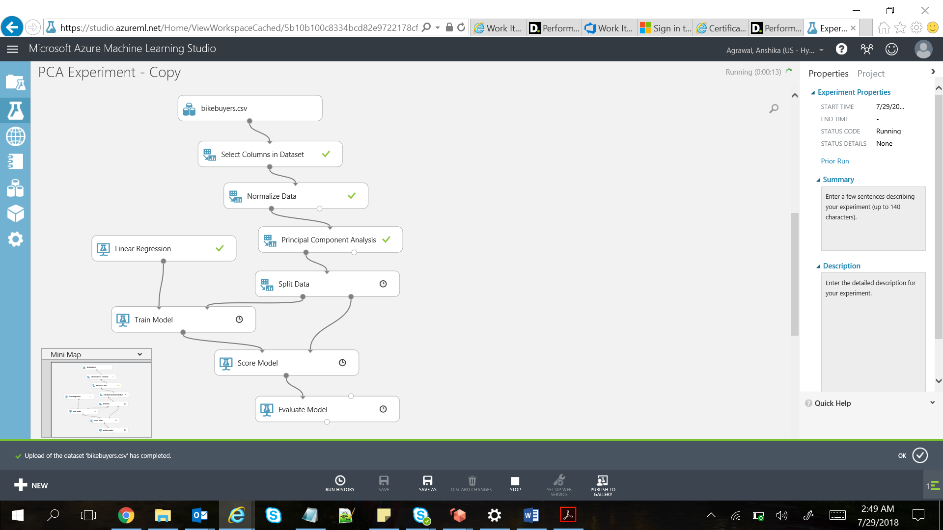

**Results:**

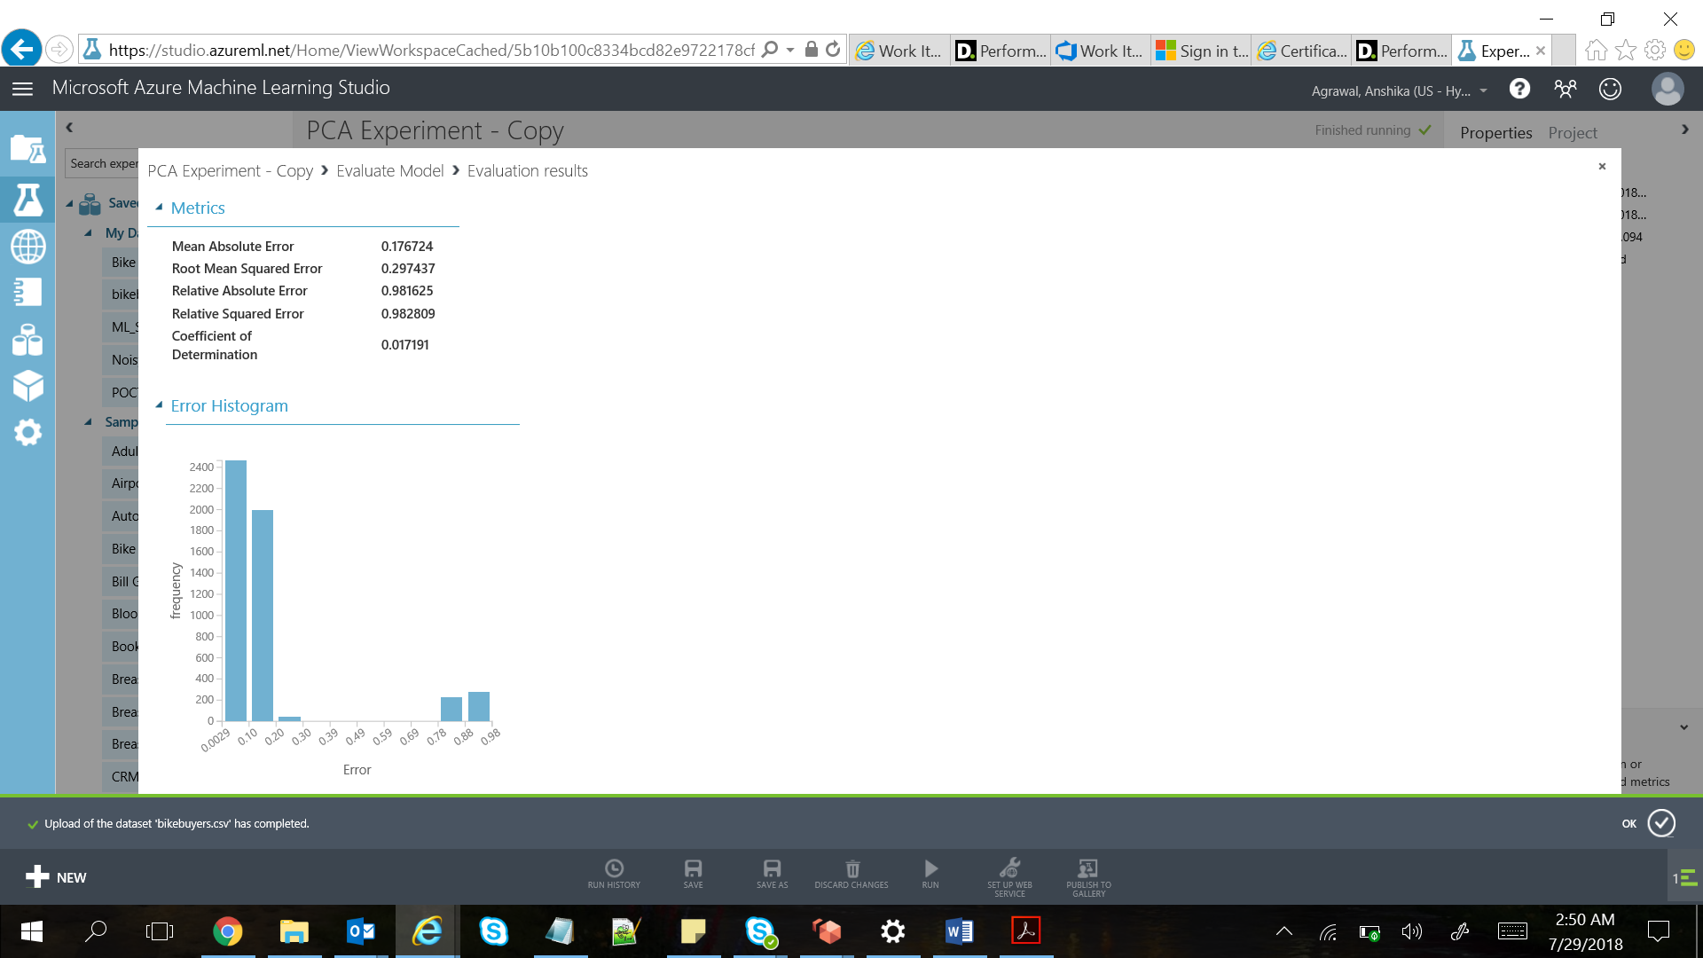

# **K-Means Clustering**

K-means is one of the simplest and the best known unsupervised learning algorithms, and can be used for a variety of machine learning tasks, such as detecting abnormal data, clustering of text documents, and analysis of a dataset prior to using other classification or regression methods

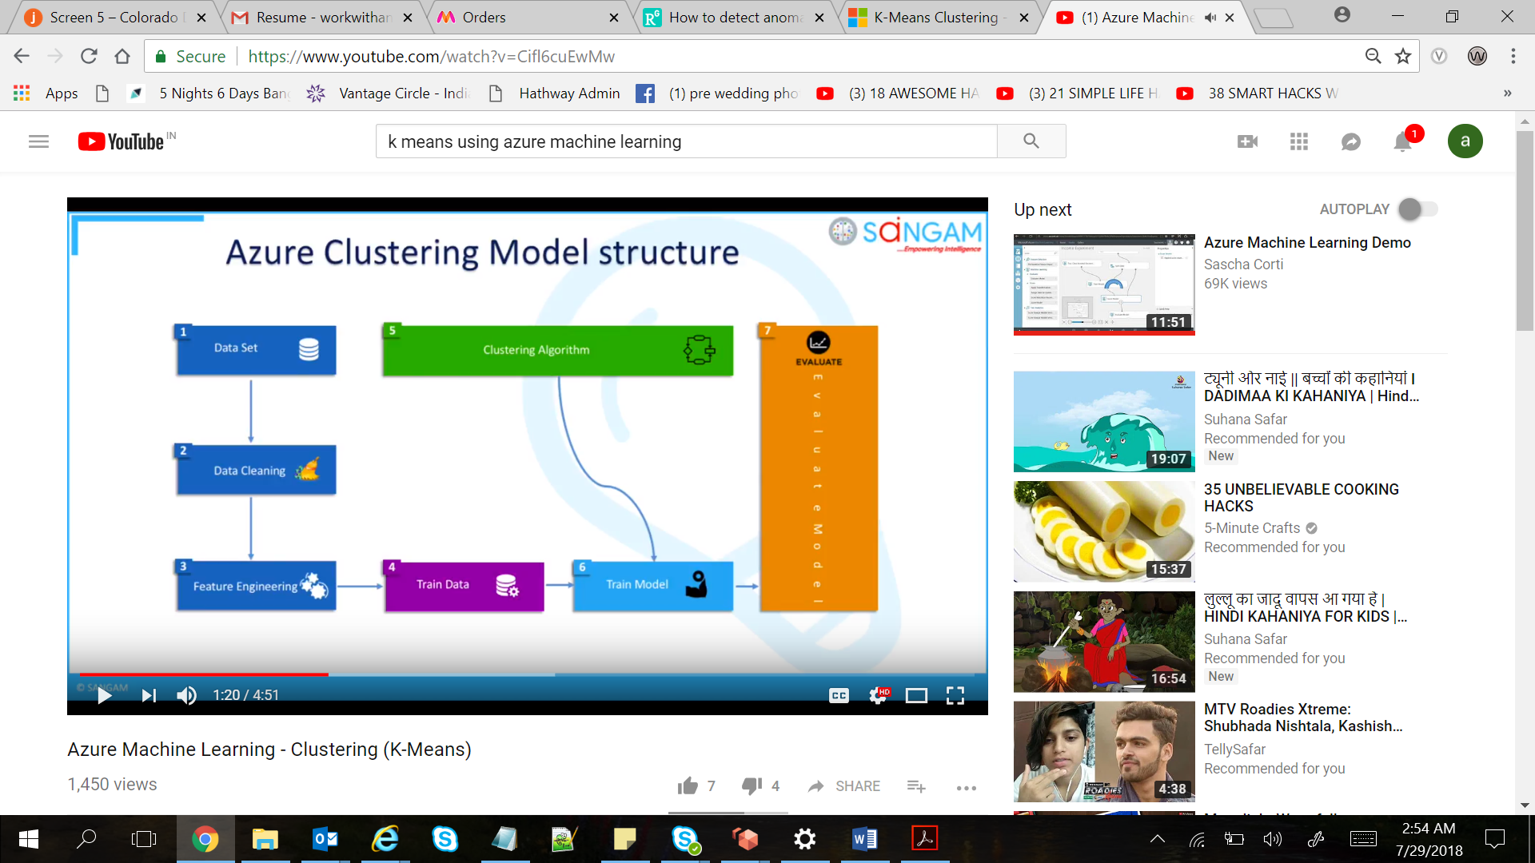

Understanding k-means clustering:

In general, clustering uses iterative techniques to group cases in a dataset into clusters that contain similar characteristics. These groupings are useful for exploring data, identifying anomalies in the data, and eventually for making predictions. Clustering models can also help you identify relationships in a dataset that you might not logically derive by browsing or simple observation. For these reasons, clustering is often used in the early phases of machine learning tasks, to explore the data and discover unexpected correlations.

When you configure a clustering model using the k-means method, you must specify a target number k indicating the number of centroids you want in the model. The centroid is a point that is representative of each cluster. The K-means algorithm assigns each incoming data point to one of the clusters by minimizing the within-cluster sum of squares.

When processing the training data, the K-means algorithm begins with an initial set of randomly chosen centroids, which serve as starting points for each cluster, and applies Lloyd's algorithm to iteratively refine the locations of the centroids. The K-means algorithm stops building and refining clusters when it meets one or more of these conditions:

* The centroids stabilize, meaning that cluster assignments for individual points no longer change and the algorithm has converged on a solution.
* The algorithm completed running the specified number of iterations.

After completing the training phase, you use the Assign Data to Clusters module to assign new cases to one of the clusters that was found by the k-means algorithm. Cluster assignment is performed by computing the distance between the new case and the centroid of each cluster. Each new case is assigned to the cluster with the nearest centroid.

**Dataset used:**

Input we are using:



**Dataset Snippet:**

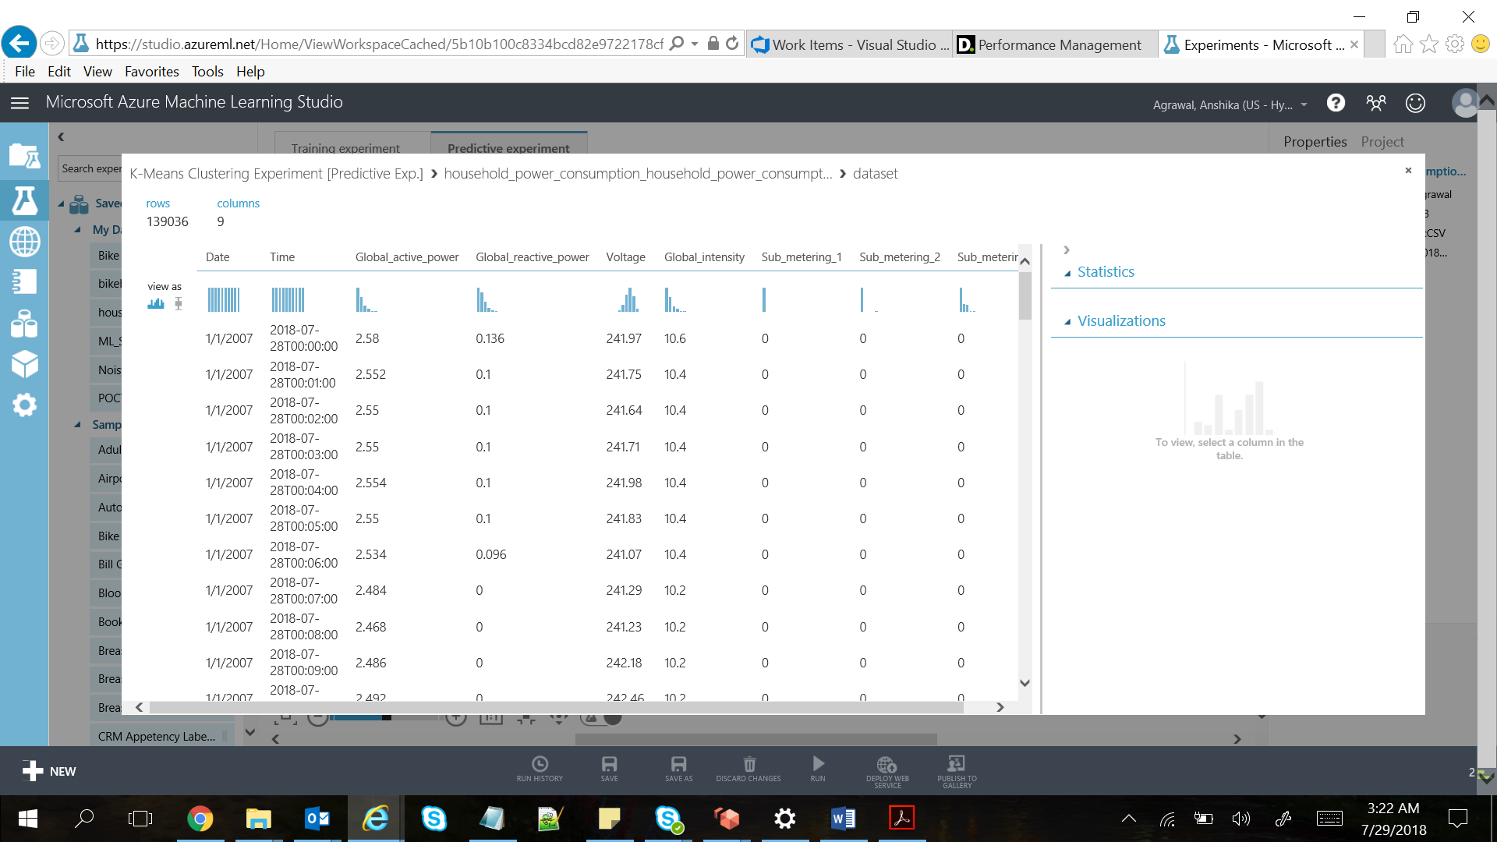

**Experiment:**

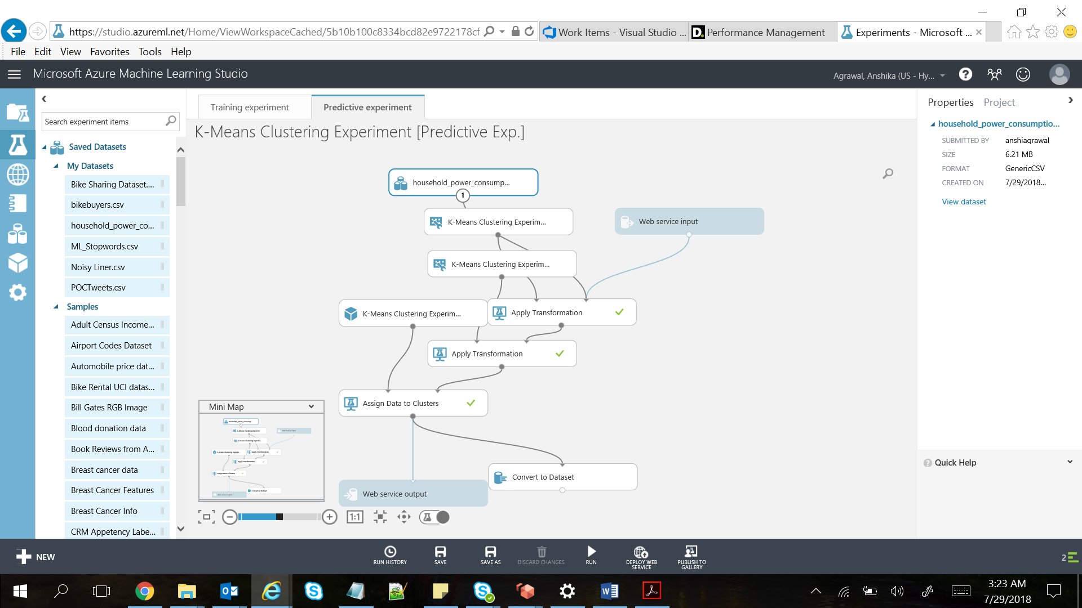

**Results:**

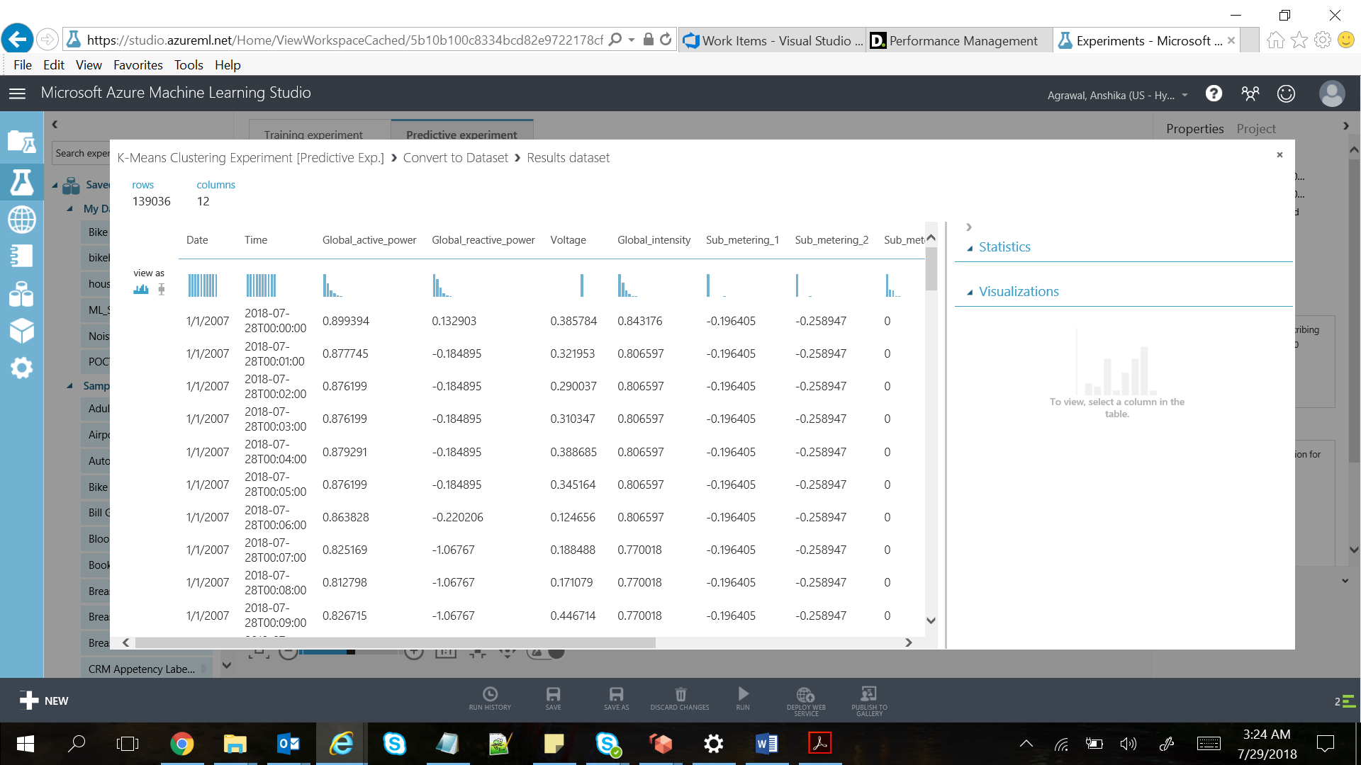

# **Two-Class Support Vector Machine**

Support vector machines (SVMs) are a well-researched class of supervised learning methods. This particular implementation is suited to prediction of two possible outcomes, based on either continuous or categorical variables.

Support vector machines are among the earliest of machine learning algorithms, and SVM models have been used in many applications, from information retrieval to text and image classification. SVMs can be used for both classification and regression tasks.

This SVM model is a supervised learning model that requires labeled data. In the training process, the algorithm analyzes input data and recognizes patterns in a multi-dimensional feature space called the hyperplane. All input examples are represented as points in this space, and are mapped to output categories in such a way that categories are divided by as wide and clear a gap as possible.

For prediction, the SVM algorithm assigns new examples into one category or the other, mapping them into that same space.

**Dataset used:**

Input we are using:



**Dataset Snippet:**

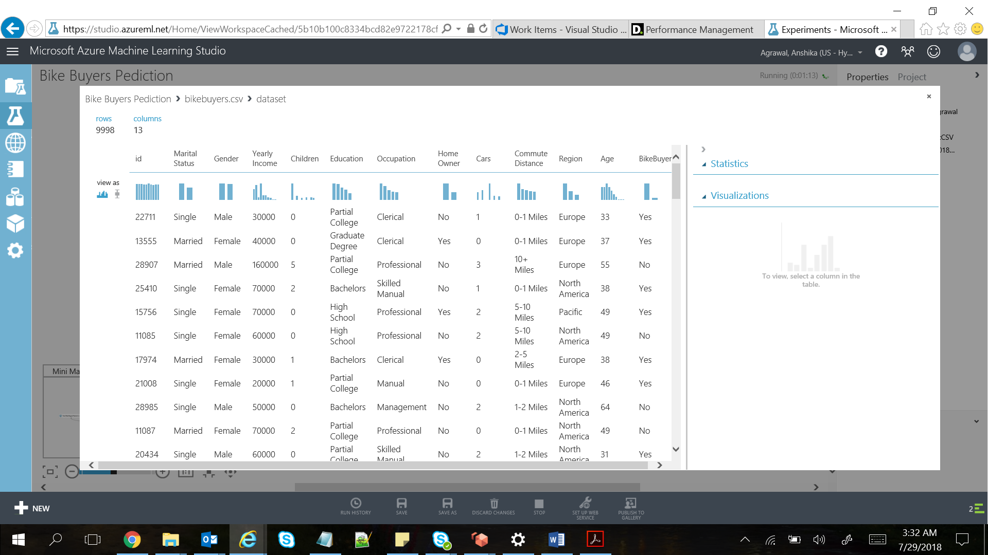

**Experiment:**

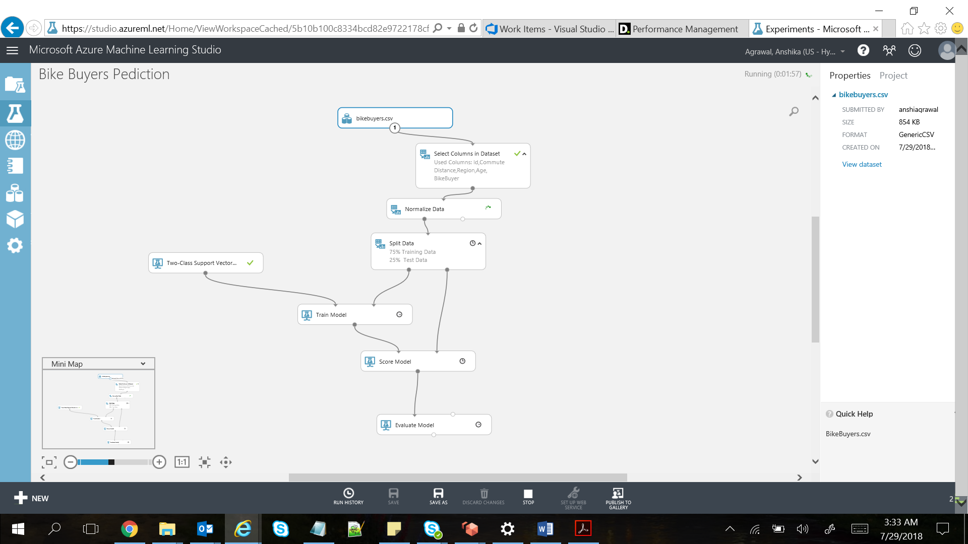

**Results:**

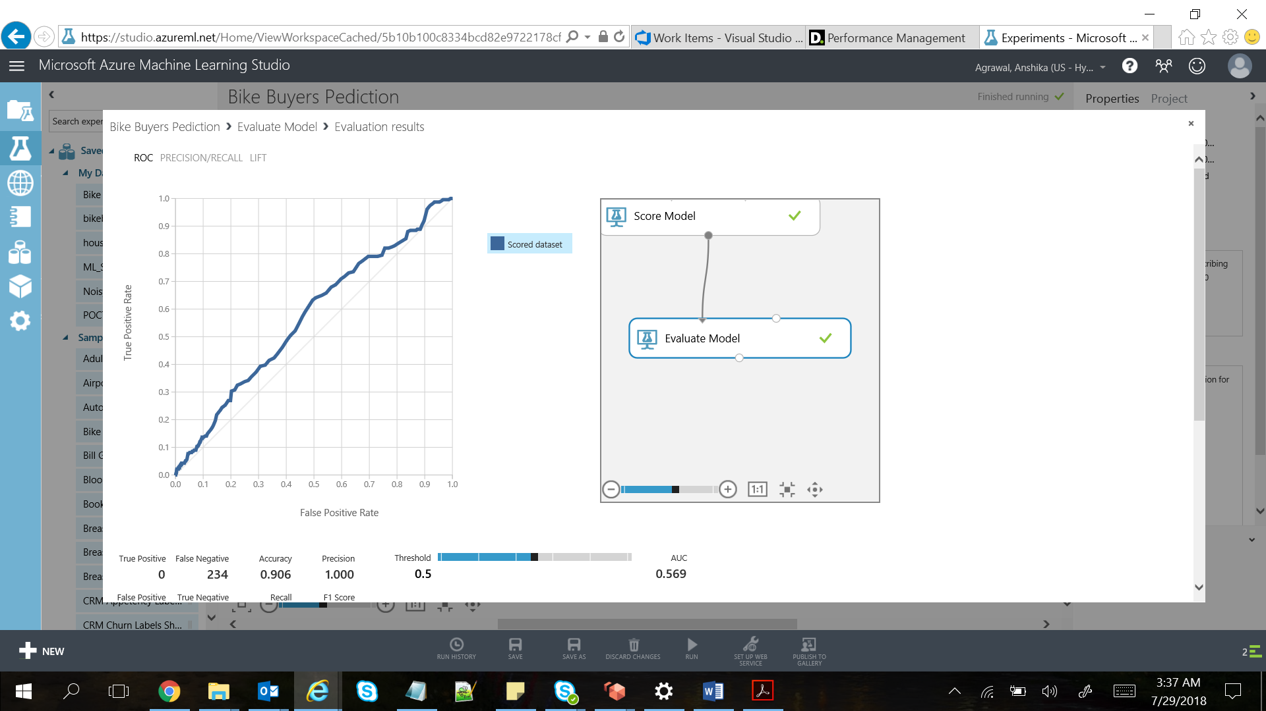



# **Two-Class decision forest**

Decision forest algorithm is an ensemble learning method intended for classification tasks. Ensemble methods are based on the general principle that rather than relying on a single model, you can get better results and a more generalized model by creating multiple related models and combining them in some way. Generally, ensemble models provide better coverage and accuracy than single decision trees.

**Experiment:-**

This sample demonstrates how to use multiclass classifiers and feature hashing in Azure ML Studio to classify news into different categories.

**Dataset Used:-**



## **Data Preparation**

Because the original Reuters data did not have column headings, after reading the data from storage we replaced the dummy column headings with meaningful column names, using **Metadata Editor**.

For the label data, we used only the rows already tagged with hierarchy names (CCAT,ECAT,GCAT,MCAT). Then we joined the label data to tag the unlabeled train and test data by using the **Join** module. We also removed duplicate rows using the **Remove Duplicate Rows** module.

## **Feature Engineering**

We used the **Feature Hashing** module to convert the plain text of the articles to integers and used the integer values as input features to the model. 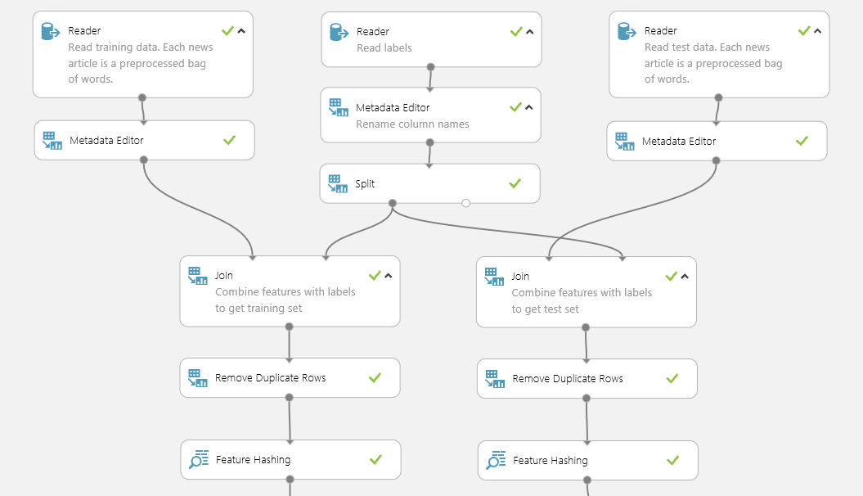

## **Model**

We compared two nonlinear multiclass classifiers:

* **Multiclass Decision Forest**
* **One-vs-All** classifier using the **Two-Class Decision Forest** module for the base classifier

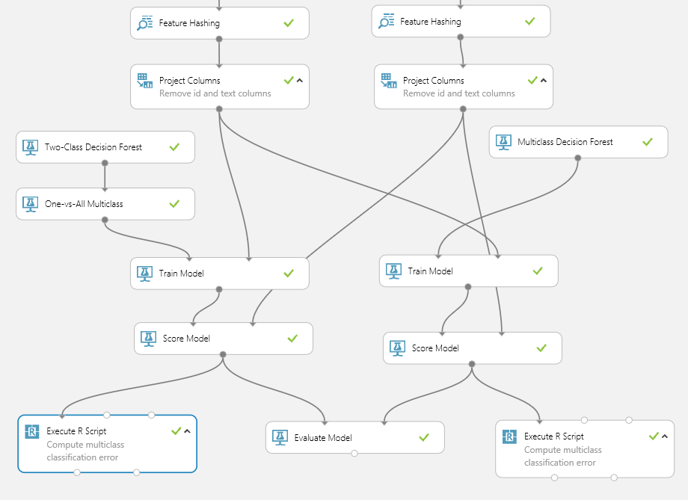

## **Results**

All accuracy values were computed and compared using custom script in the **Execute R Script** module. The following graphic showed the confusion matrices for the **One-vs-All** classifier on the left, and the **Multiclass Decision Forest** model on the right. 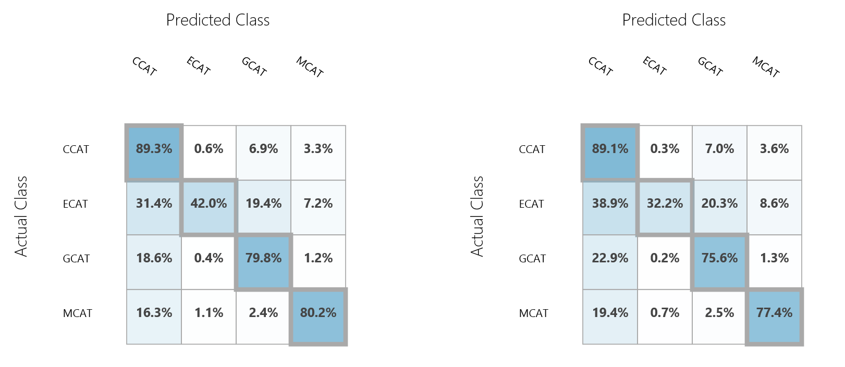

# **Two-Class Decision Jungle**

[Decision jungles](http://go.microsoft.com/fwlink/?LinkId=403675) are a recent extension to [decision forests](http://go.microsoft.com/fwlink/?LinkId=403677). A decision jungle consists of an ensemble of decision directed acyclic graphs (DAGs).

Decision jungles have the following advantages:

* By allowing tree branches to merge, a decision DAG typically has a lower memory footprint and better generalization performance than a decision tree, albeit at the cost of somewhat longer training time.
* Decision jungles are non-parametric models that can represent non-linear decision boundaries.
* They perform integrated feature selection and classification and are resilient in the presence of noisy features.

**Experiment:-**

To Predict Survivors of the Titanic using Machine Learning Techniques.

**Input Data:-**



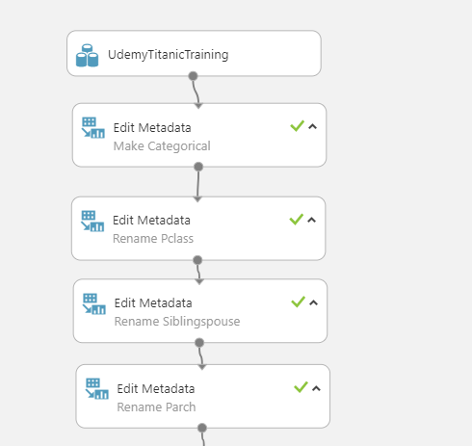

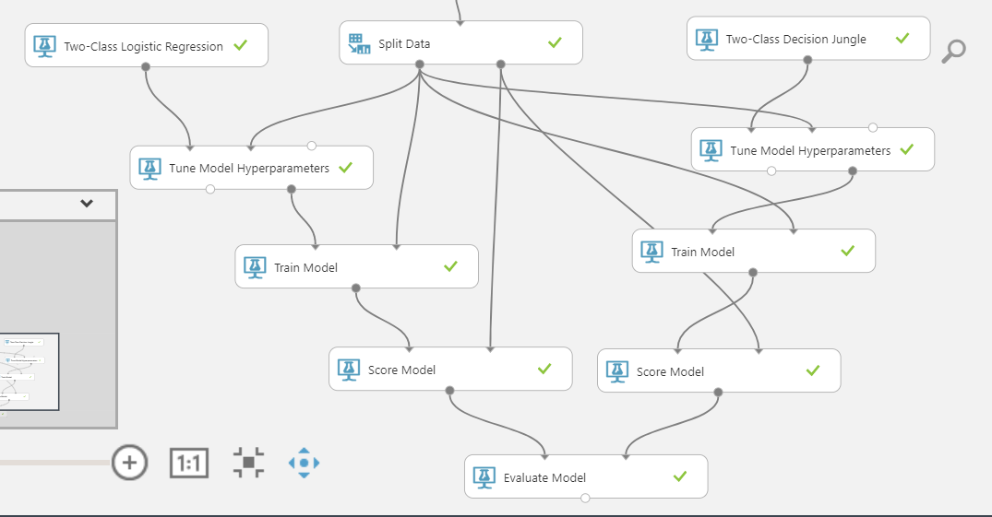

**Output:-**

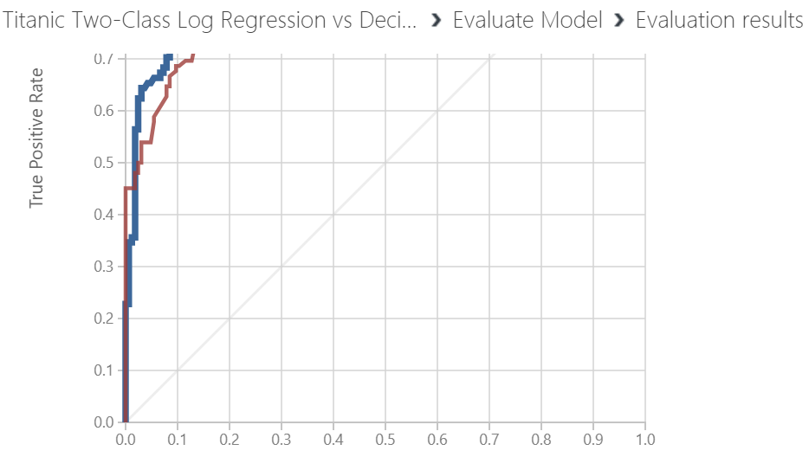

# **Two-class locally deep SVM**

Support vector machines (SVMs) are an extremely popular and well-researched class of supervised learning models, which can be used in linear and non-linear classification tasks. Recent research has focused on ways to optimize these models to efficiently scale to larger training sets. In this implementation from Microsoft Research, the kernel function that is used for mapping data points to feature space is specifically designed to reduce the time needed for training while maintaining most of the classification accuracy.

This model is a supervised learning method, and therefore requires a tagged dataset, which includes a label column.

**Experiment:-**

Sample experiment that shows how to compare performance of multiple learning algorithms.

**Input Data:-**



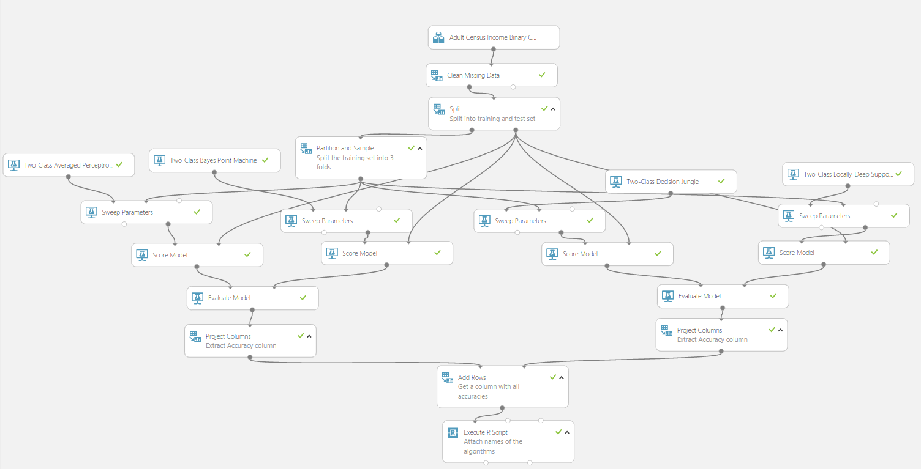

## **Dataset and problem description**

We use 'Adult Census Income' dataset, with 'income' being a label column. This column indicated whether person's income exceeds $50K/yr. The dataset is prepopulated in your workspace and is originally downloaded from [UCI Repository](http://archive.ics.uci.edu/ml/datasets/Adult).

## **Data preprocessing**

We replace all missing values with "0" using **Missing Value Scrubber** module. Initially we use **Split** module to randomly split the dataset into training and test sets.

## **Comparison of classifiers**

We compare 4 binary classifiers: **Two-Class Averaged Perceptron**, **Two-Class Bayes Point Machine**, **Two-Class Decision Jungle** and **Two-Class Locally-Deep Support Vector Machine**. The comparison is done by performing the following steps:

1. 3-fold cross-validation over the training set
2. finding the best hyperparameters of each learning algorithm
3. training each learning algorithm over the training set using previously found algorithm's best values of hyperparameters
4. scoring the test set
5. computing accuracy over the test set

The first three steps are done by **Sweep Parameters** module. By default **Sweep Parameters** module in cross-validation mode partitions the training set into 10-folds. To change the number of folds we use **Partition and Sample** module with the following parameters:

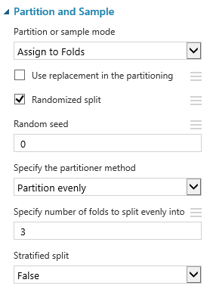

We connect partitioned training set to 'training dataset' input of **Sweep Parameters**. Since we use **Sweep Parameters** in cross-validation mode, we leave module's right output unconnected. We use default values of **Sweep Parameters** that find the hyperparameters that optimize accuracy.

The fourth and fifth steps in the above list are done by **Score Model** and **Evaluate Model** respectively. **Evaluate Model** computes many metrics. We extract Accuracy metric using **Project Column** module. Finally, we use **Add Rows** and **Execute R Script** to combine results of all learners into a single column and to add a column with the names of the algorithms. R code that is used in **Execute R** is given below: dataset <- maml.mapInputPort(1) Algorithm <- c("Averaged Perceptron","Bayes Point Machine", "Decision Jungle", "Locally-Deep SVM") data.set <- cbind(Algorithm, dataset) maml.mapOutputPort("data.set")

To compare performance of classifiers according to other metric (e.g. AUC) we will need to change 'Metric for measuring performance for classification' parameter to that metric. Also we will need to change ***Project Columns*** to project to that metric and update R code in ***Execute R*** with the name of the new metric.

## **Results**

The final output of the experiment is the left output of the last **Execute R Script** module:

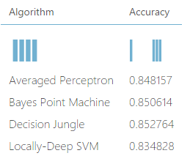

# **Two-class neural network**

A neural network is a set of interconnected layers. The inputs are the first layer, and are connected to an output layer by an acyclic graph comprised of weighted edges and nodes.

Between the input and output layers you can insert multiple hidden layers. Most predictive tasks can be accomplished easily with only one or a few hidden layers. However, recent research has shown that deep neural networks (DNN) with many layers can be very effective in complex tasks such as image or speech recognition. The successive layers are used to model increasing levels of semantic depth.

**Experiment:-**

This experiment demonstrates the usage of the two class neural network module on the telescope data set.

**Input Data:-**



In this experiment a two class neural network module is used to train models to recognize gamma (signal), hadron (background) in a ground-based atmospheric Cherenkov gamma telescope.

Cherenkov gamma telescope observes high energy gamma rays, taking advantage of the radiation emitted by charged particles produced inside the electromagnetic showers initiated by the gammas, and developing in the atmosphere. This Cherenkov radiation (of visible to UV wavelengths) leaks through the atmosphere and gets recorded in the detector, allowing reconstruction of the shower parameters. The available information consists of pulses left by the incoming Cherenkov photons on the photomultiplier tubes, arranged in a plane, the camera.

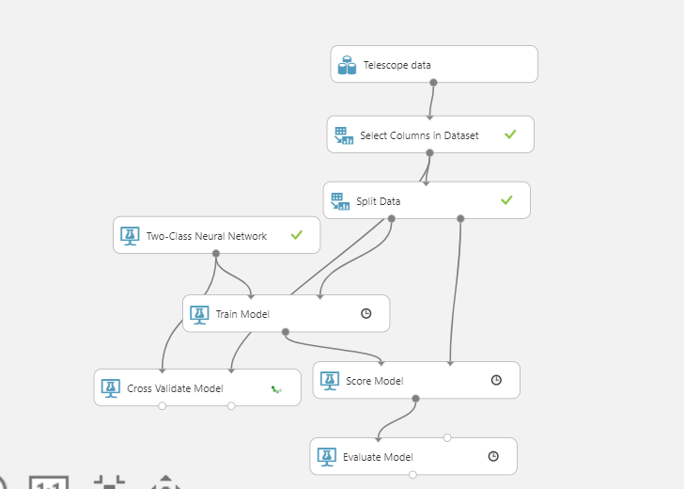

**Results:-**

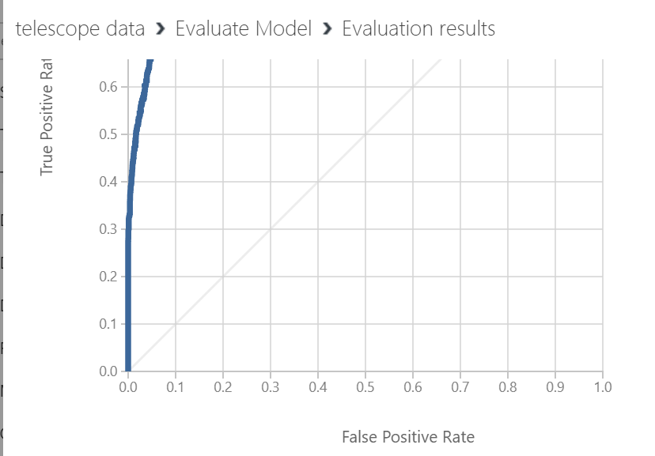

# **Fast Forest Quantile Regression**

Quantile regression is useful if we want to understand more about the distribution of the predicted value, rather than get a single mean prediction value. This method has many applications, including:

* Predicting prices
* Estimating student performance or applying growth charts to assess child development
* Discovering predictive relationships in cases where there is only a weak relationship between variables

This regression algorithm is a **supervised** learning method, which means it requires a tagged dataset that includes a label column. Because it is a regression algorithm, the label column must contain only numerical values.

**Experiment:-**

Linear regression models predict the mean of the target column given input features. In some applications such as price prediction we are interested in predicting the range or entire distribution of the target column instead of a single estimate. In this experiment, we attempt to predict the 25th, 50th and 75th percentiles for the price for an automobile given is other attributes. We use a tree-based quantile estimator that can handle non-gaussian distributions.

**Input Data:-**



# **Quantile Regression: Car price prediction**

In this experiment, we attempt to predict the 25th, 50th and 75th percentiles for the price for an automobile given some attributes.

## **Model**

### Data Pre-processing

The first step is data preprocessing, using the following modules:

1. The **Clean Missing Data** module is used to replace missing values with zeros.
2. The data is split into 80% training and 20% testing sets using the **Split** module.

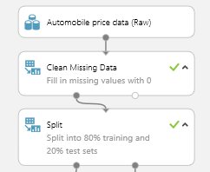

### Parameters

There are two ways that you can set parameters for the **Fast Forest Quantile Regression** module, using the **Create trainer mode** option in the module properties:

* Single Parameter: If you use this option, you specify parameters of the learner manually.
* Parameter Range: If you use this option, you should obtain the parameters by using the **Sweep Parameters** module. Multiple values or a range of values can be specified for each tunable parameter. In this experiment, we used a grid sweep to optimize the values for each of the tunable parameters.

**Required Quantile Values**: You can predict multiple quantile values using a single module. In this experiment, we will output the 25th, 50th and 75th percentile predictions from the same model.

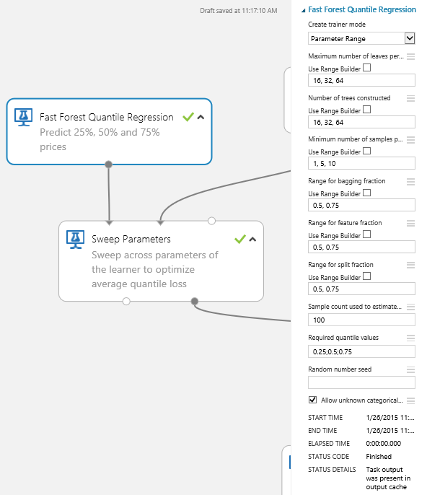

### Sweep Parameters

The **Sweep Parameters** module is used to select the best combination of parameters from among the selected parameters and possible parameter values. Since we do not have a separate set of validation data, we used the training data to perform cross validation to optimize the parameters.

When predicting multiple quantiles, a separate loss function is associated with each quantile. The **Sweep Parameters** module optimizes for the average quantile loss across all the specified quantiles.

### Training

One of the outputs of the **Sweep Parameters** module is a learner with settings that have been optimized for the average quantile loss. This learner can be directly connected to the **Score Model** module to score the test set. Alternatively, we can take the learner with the optimal settings and retrain the model using all the training data. (In contrast, **Sweep Parameters** uses only a subset of the training data.) For this experiment, we choose the former approach.

### Scores

Predictions from the quantile regression model can be obtained using the generic **Score Model** module. The output provides an additional column with predictions for each of the quantiles specified.

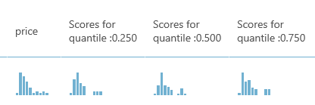

We can extract the quantile predictions from the dataset of scores by using the **Project Columns** module.

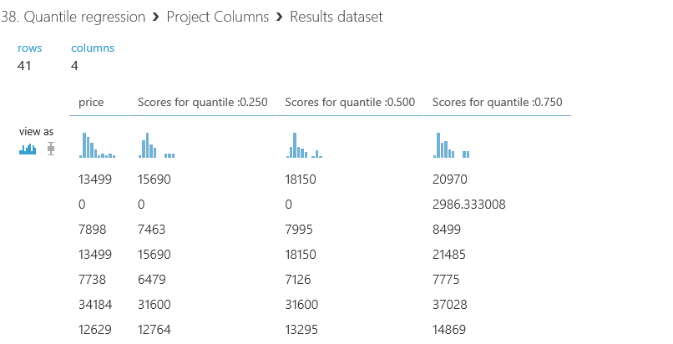

## **Evaluation Results**

Quantile regression models optimize for check loss or quantile loss. This loss is a generalization of the absolute error metric used in linear regression. More information about these loss functions can be found [here](http://en.wikipedia.org/wiki/Quantile_regression).

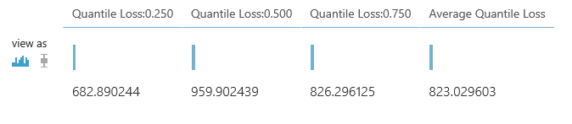

# **Neural Network Regression**

Although neural networks are known for use in deep learning and modeling complex problems such as image recognition, they are easily adapted to regression problems. Any class of statistical models can be termed a neural network if they use adaptive weights and can approximate non-linear functions of their inputs. Thus neural network regression is suited to problems where a more traditional regression model cannot fit a solution.

Neural network regression is a supervised learning method, and therefore requires a tagged dataset, which includes a label column. Because a regression model predicts a numerical value, the label column must be a numerical data type.

**Experiment:-**

Created sanity sample to investigate "neural network regression".

**Input Data:-**



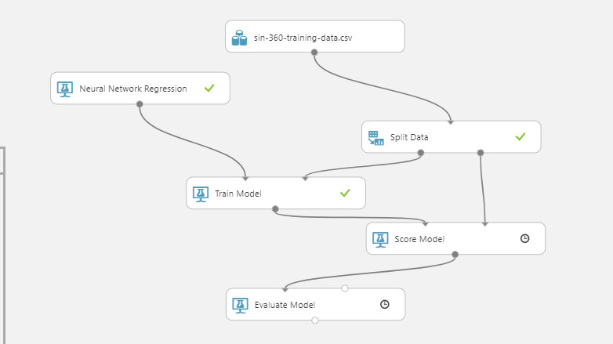

**Results:-**

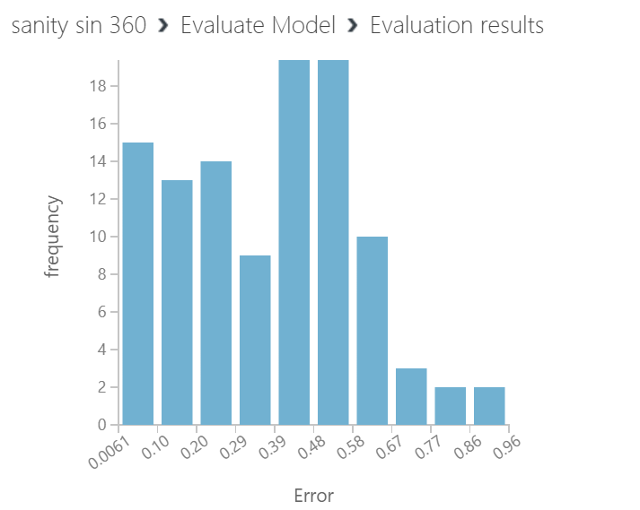

# **Decision Forest Regression**

Decision trees are non-parametric models that perform a sequence of simple tests for each instance, traversing a binary tree data structure until a leaf node (decision) is reached.

Decision trees have these advantages:

* They are efficient in both computation and memory usage during training and prediction.
* They can represent non-linear decision boundaries.
* They perform integrated feature selection and classification and are resilient in the presence of noisy features.

**Experiment:-**

Analyzed GOOGL stock closing price data set by applying various regression models and comparing them on the basis of error calculations.

The data set of GOOGL's closing price is taken and is trained under Linear Regression, Decision Forest and Boosted Decision Tree regression models. The scored values are taken and a graph is plotted between the original and the scored values using Microsoft Excel. Various errors are calculated and the conclusion is drawn for the performance of the three regression models. The Input table(2).csv file which is the GOOGL stock price values, can be downloaded by opening the project in the studio. The data is split into two parts for training and testing (70:30). The output from the models run on the two split data can be visualized in Microsoft Excel by calculating the [Mean Absolute Error](https://en.wikipedia.org/wiki/Mean_absolute_error) and [Root Mean Square Error](https://en.wikipedia.org/wiki/Root-mean-square_deviation). Conclusions drawn are:

* Linear Regression is the base of all regression models and provides results that are near to satisfaction but with a greater deviation from original data.
* Boosted Decision Tree Regression gives a distorted line which is not suitable for our case in predicting Stock Price which has to be very near to the actual solution.
* Decision Forest Tree Regression model stands out to be the best model for Stock Price with the least error.

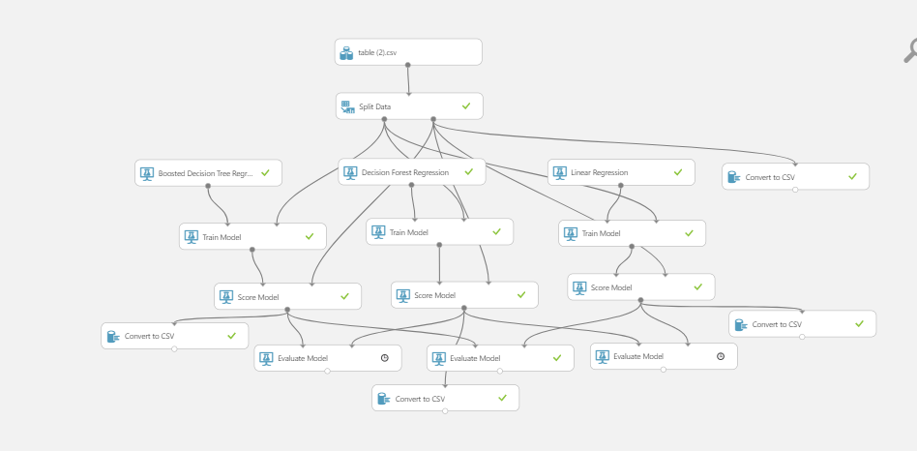

**Results:-**

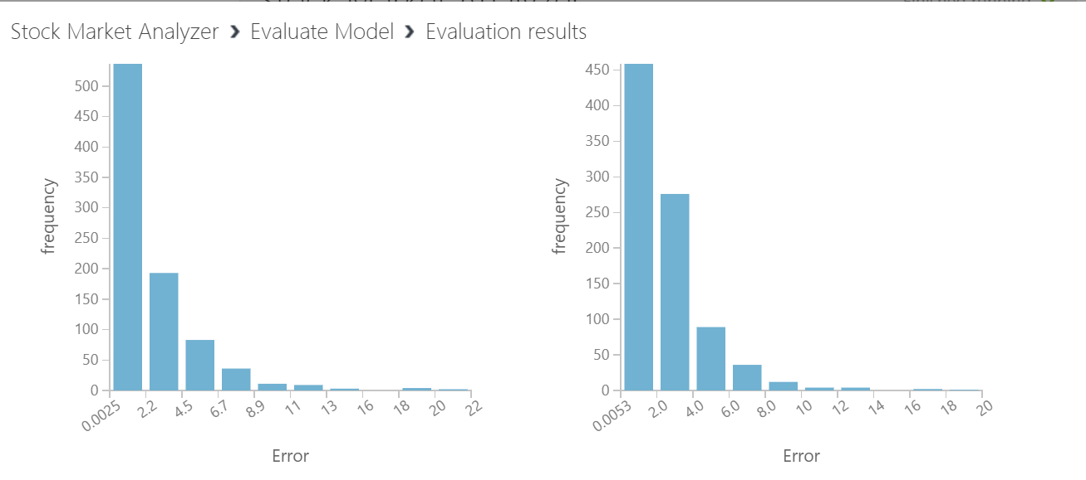

# **Ordinal Regression**

Ordinal regression is used when the label or target column contains numbers, but the numbers represent a ranking or order rather than a numeric measurement.

Predicting ordinal numbers requires a different algorithm than predicting the values of numbers on a continuous scale, because the numbers assigned to represent rank order do not have intrinsic scale.

For example, to predict students’ test scores, you would use a standard regression model, because students’ test scores vary on a continuous scale and can be measured. However, to predict their class ranking, you must use an ordinal regression model.

**Model using Azure Machine Learning Studio:**

To demonstrate we are using an example of “Bike Buyers Prediction”.

**Dataset used:**

Input we are using:



**Dataset Snippet:**



**Experiment:**

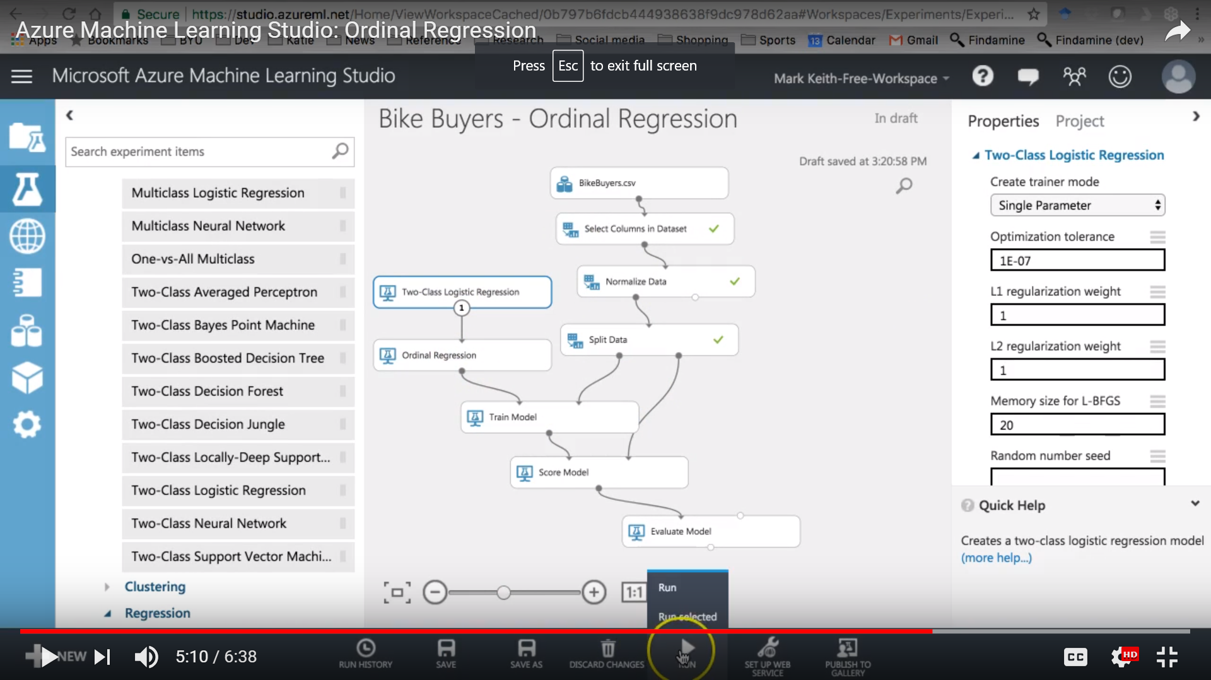

**Results:**

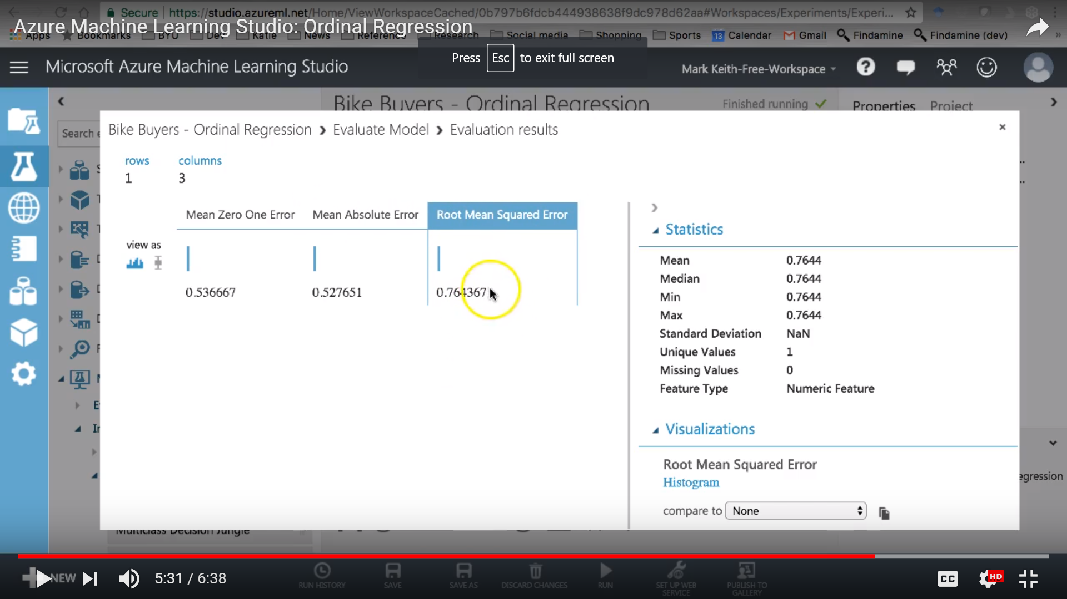

# **Poisson Regression**

Poisson regression is intended for use in regression models that are used to predict numeric values, typically counts. Therefore, we should use this module to create your regression model only if the values we are trying to predict fit the following conditions:

* The response variable has a Poisson distribution.
* Counts cannot be negative. The method will fail outright if you attempt to use it with negative labels.
* A Poisson distribution is a discrete distribution; therefore, it is not meaningful to use this method with non-whole numbers.

Poisson regression is a special type of regression analysis that is typically used to model counts. For example, Poisson regression would be useful in these scenarios:

* Modeling the number of colds associated with airplane flights
* Estimating the number of emergency service calls during an event
* Projecting the number of customer inquiries subsequent to a promotion
* Creating contingency tables

Because the response variable has a Poisson distribution, the model makes different assumptions about the data and its probability distribution than, say, least-squares regression. Therefore, Poisson models should be interpreted differently from other regression models.

**Model using Azure Machine Learning Studio:**

To demonstrate we are using an example of “Bike Buyers Prediction”.

**Dataset used:**

Input we are using Twitter Data.

**Dataset Snippet:**

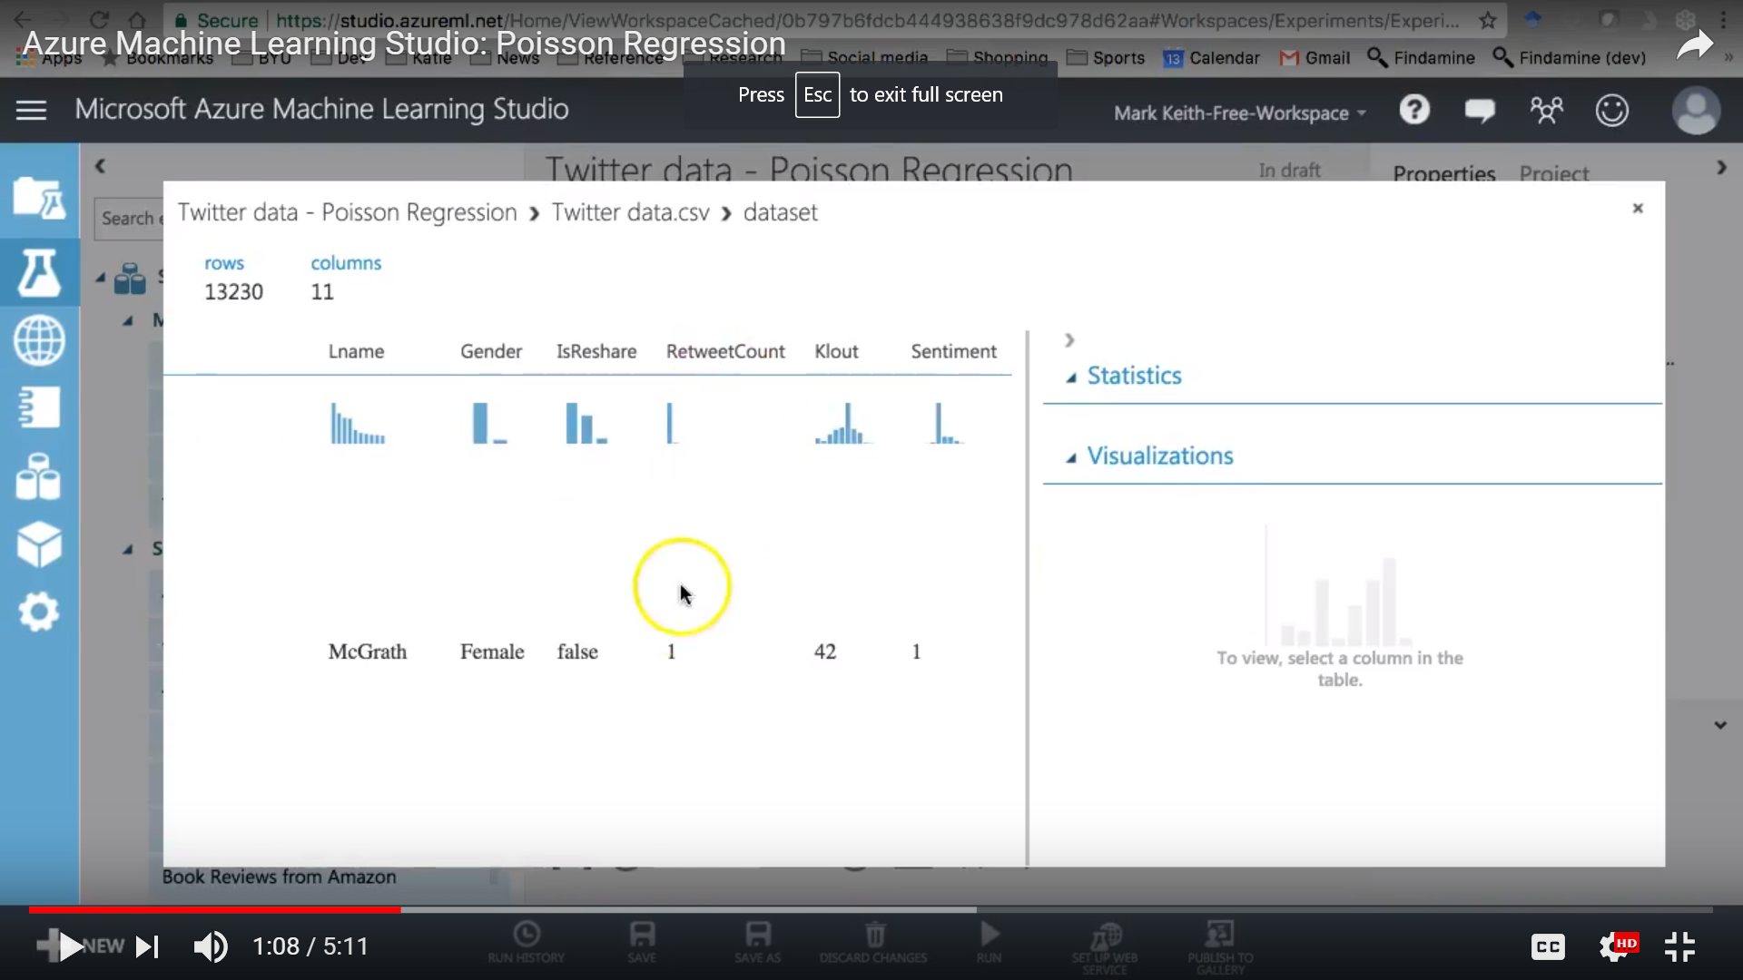

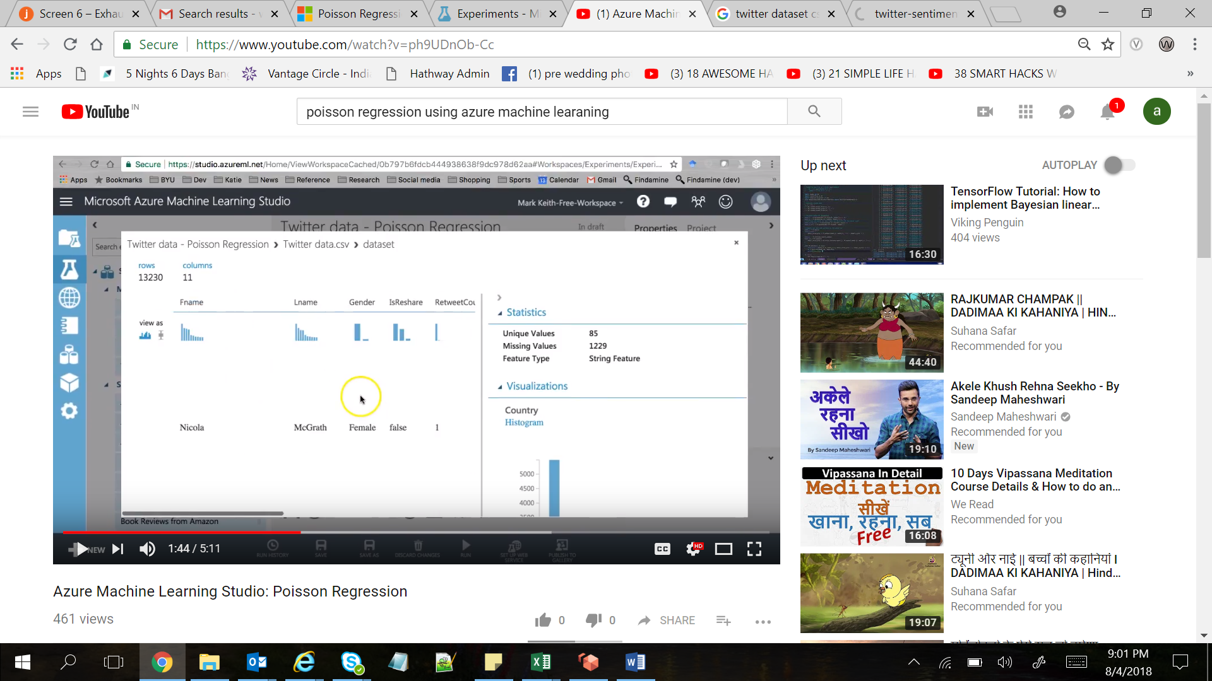

**Experiments:**

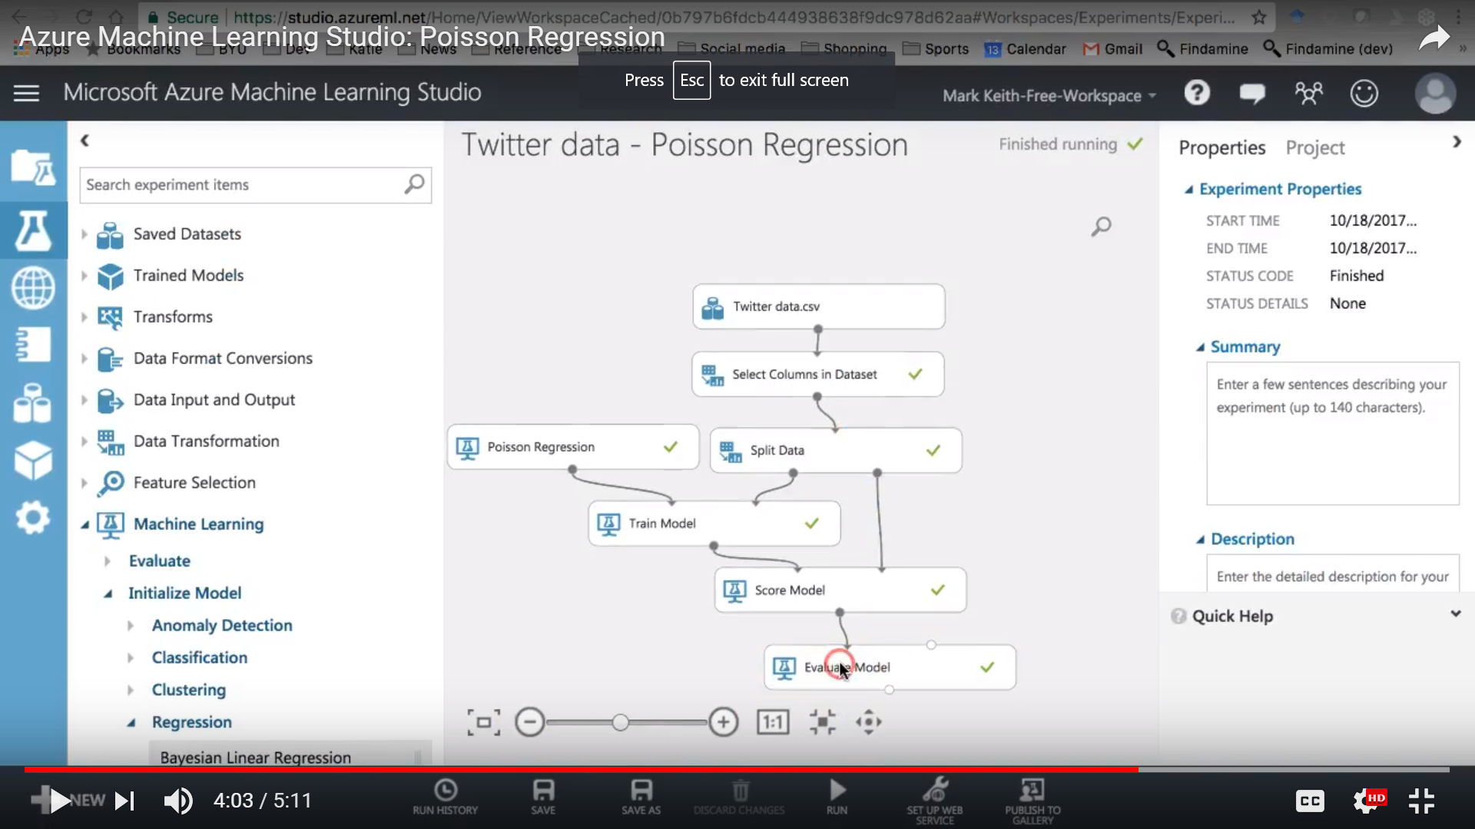

**Results:**

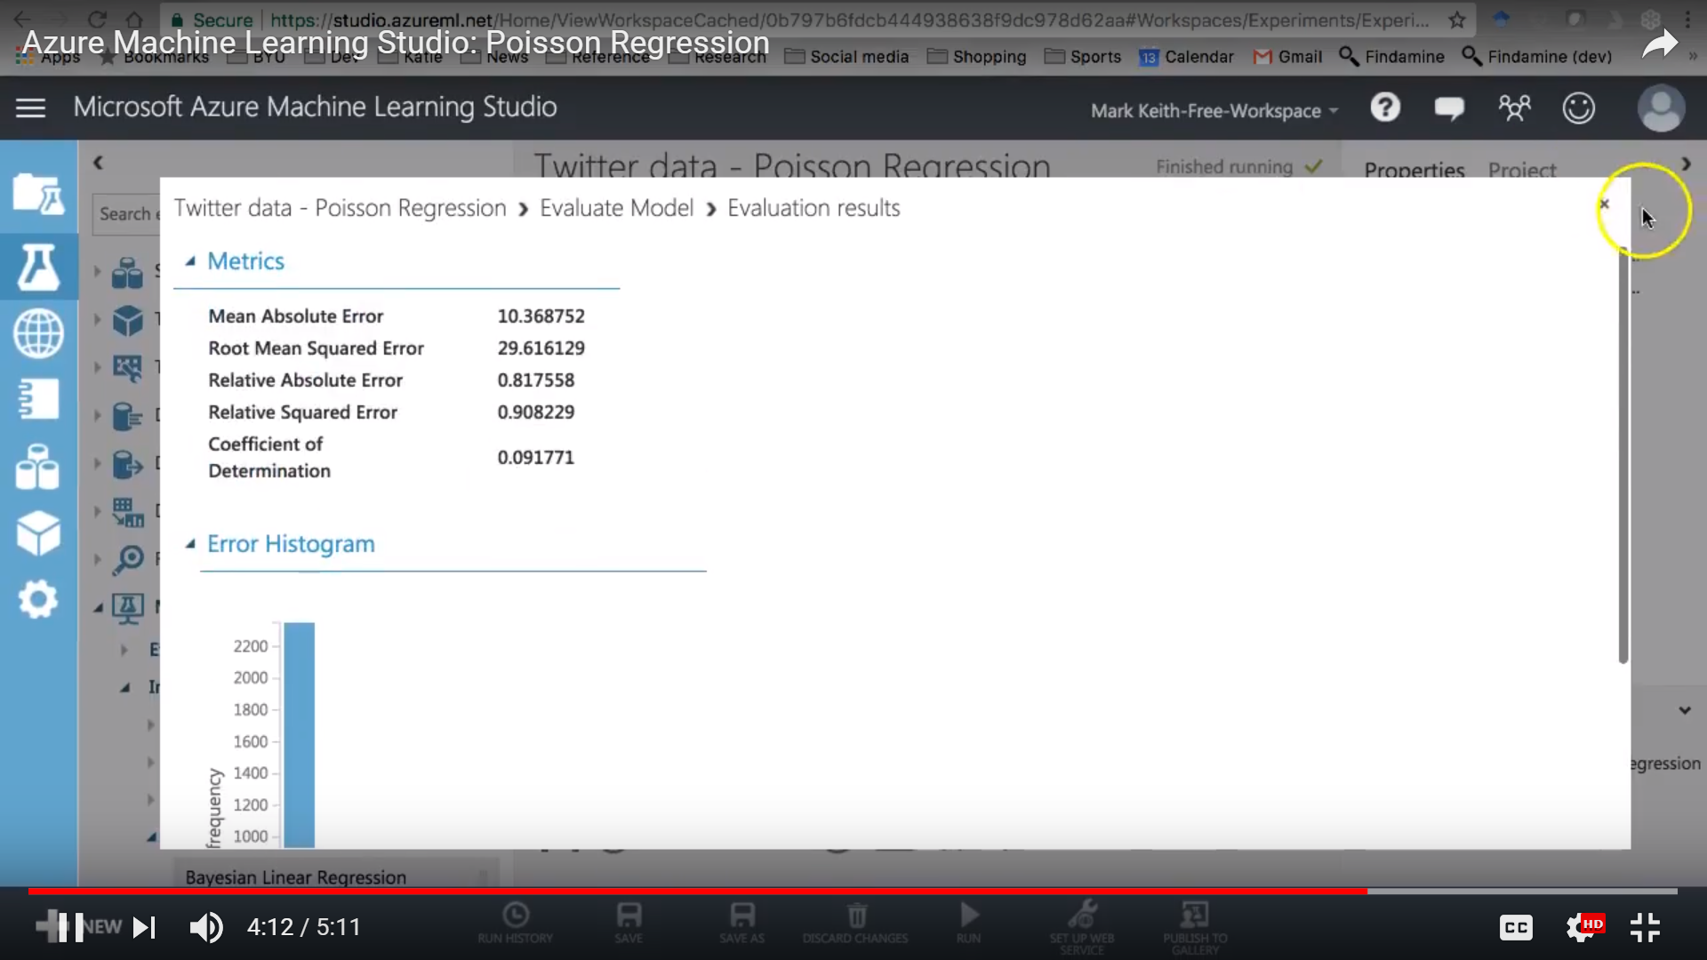

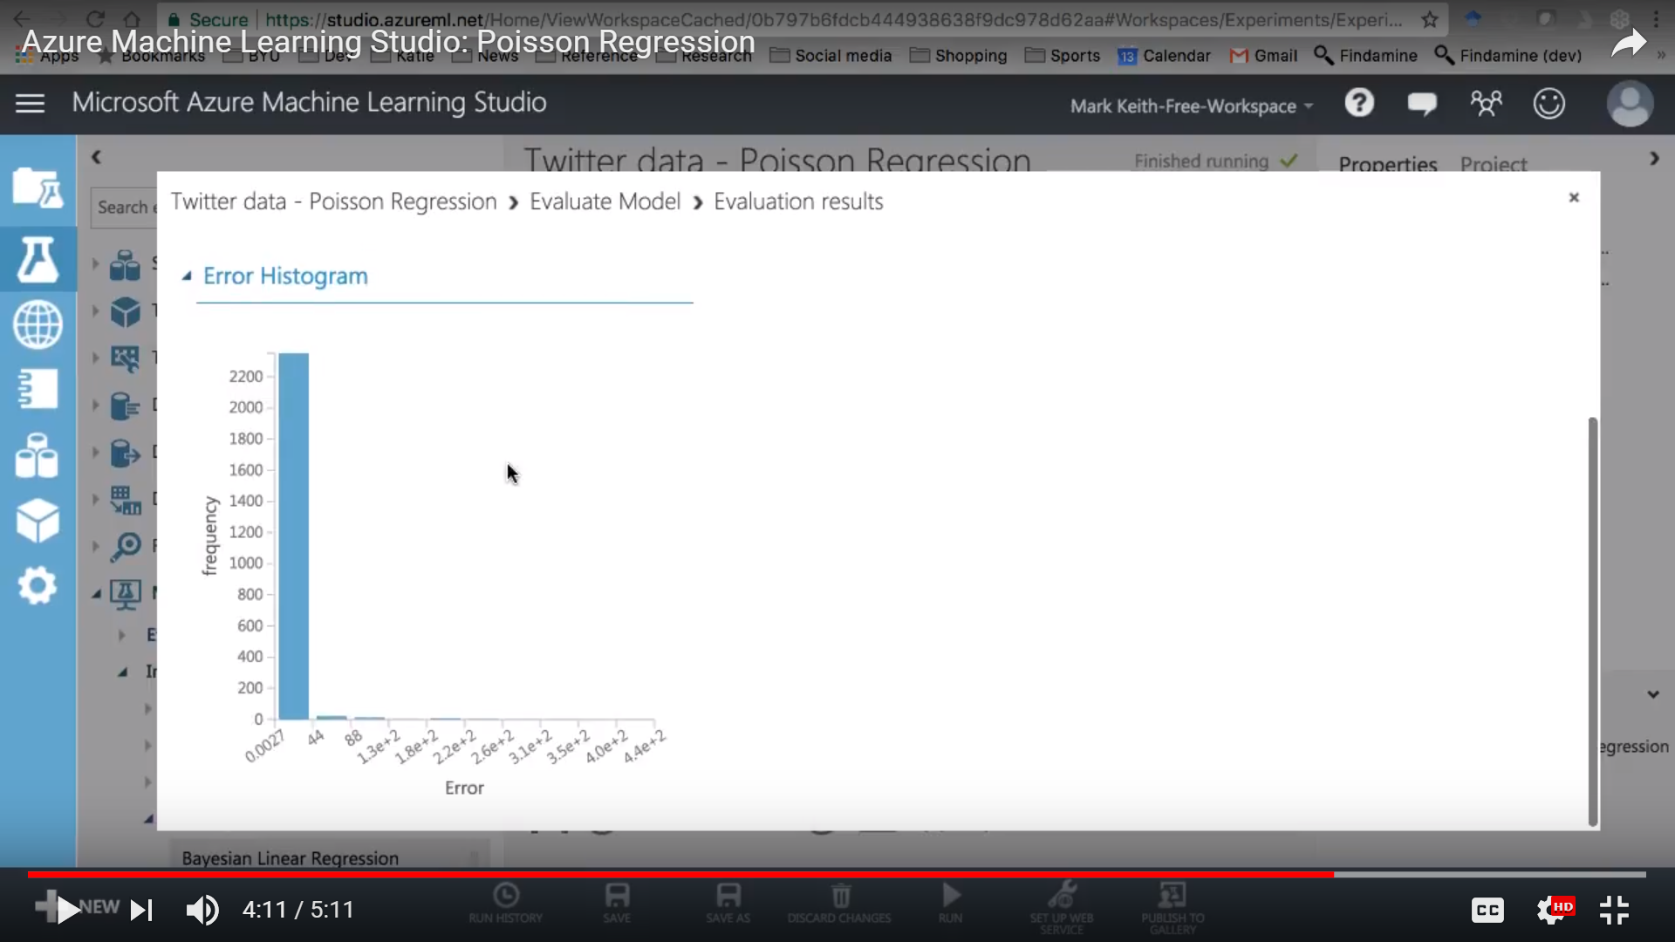

# **Bayesian Linear Regression**

In statistics, the *Bayesian* approach to regression is often contrasted with the frequentist approach.

The Bayesian approach uses linear regression supplemented by additional information in the form of a prior probability distribution. Prior information about the parameters is combined with a likelihood function to generate estimates for the parameters.

In contrast, the frequentist approach, represented by standard least-square linear regression, assumes that the data contains sufficient measurements to create a meaningful model.

It is a very fast algorithm.

**Model using Azure Machine Learning Studio:**

To demonstrate we are using an example of “Bike Buyers Prediction”.

**Dataset used:**

Input we are using:



**Dataset Snippet:**



**Experiment:**

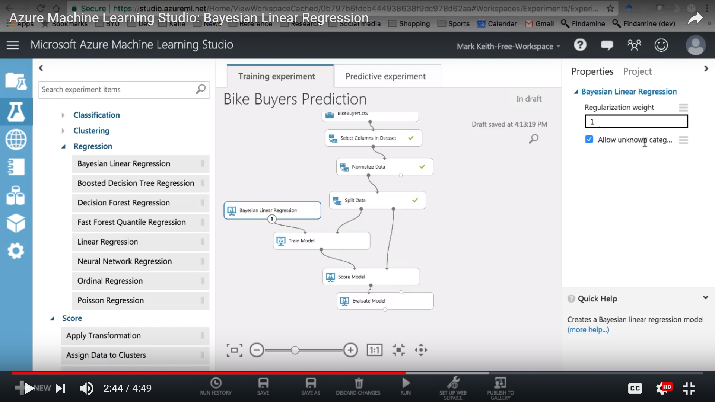

**Results:**

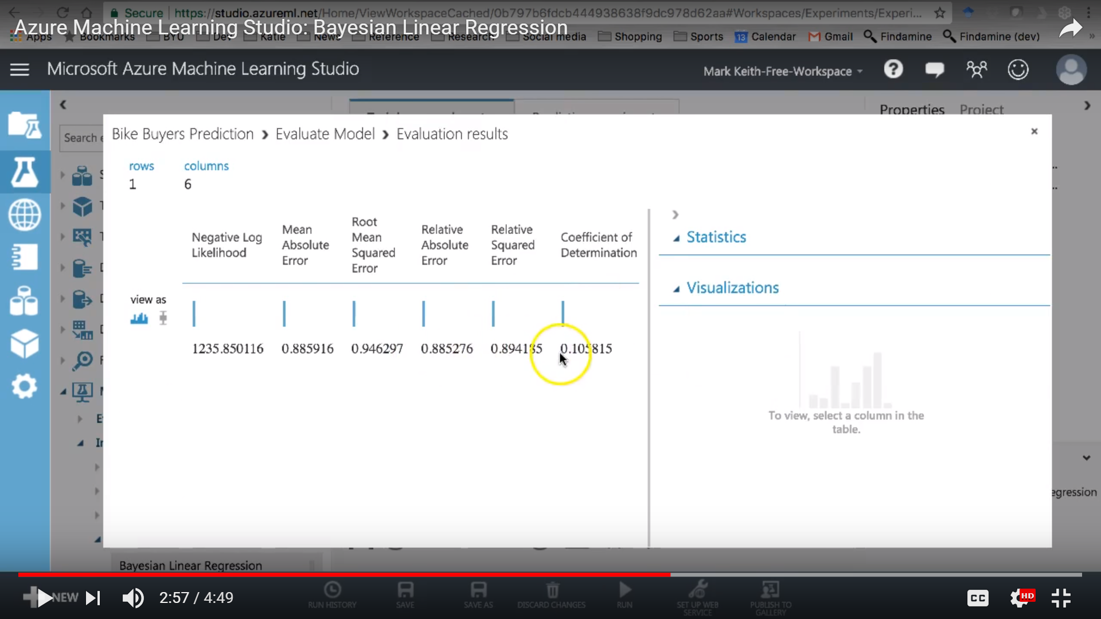

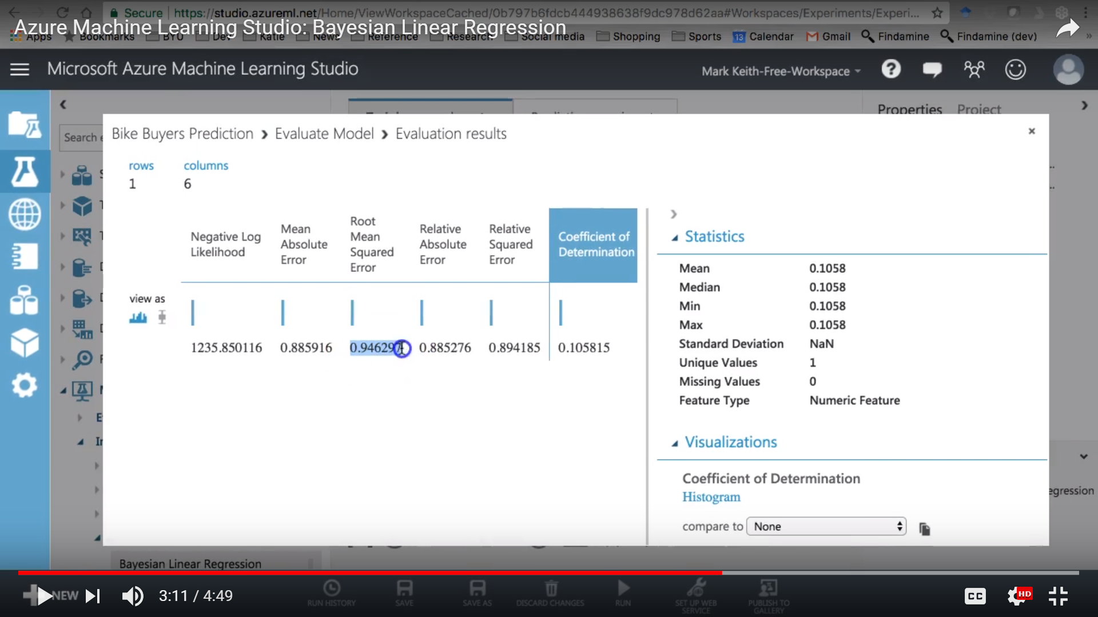

# **Two-Class logistic regression**

Logistic regression is a well-known statistical technique that is used for modeling many kinds of problems. This algorithm is a supervised learning method; therefore, we must provide a dataset that already contains the outcomes to train the model.

Logistic regression is a well-known method in statistics that is used to predict the probability of an outcome, and is especially popular for classification tasks. The algorithm predicts the probability of occurrence of an event by fitting data to a logistic function

**Model using Azure Machine Learning Studio:**

To demonstrate we are using an example of “Bike Buyers Prediction”.

**Dataset used:**

Input we are using:



**Dataset Snippet:**



**Experiment:**

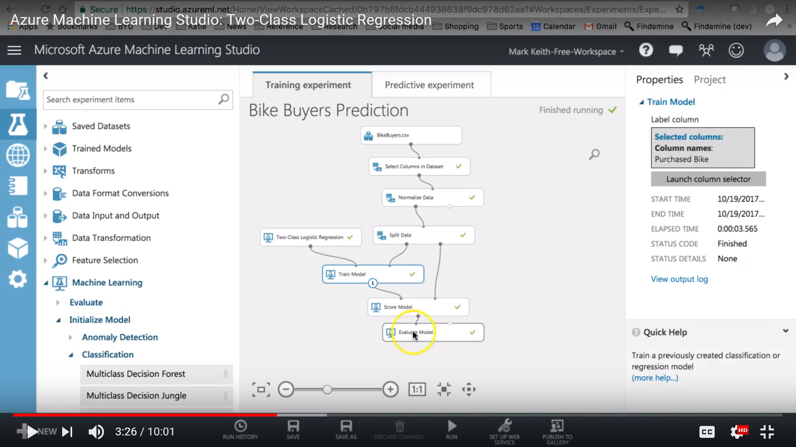

**Results:**

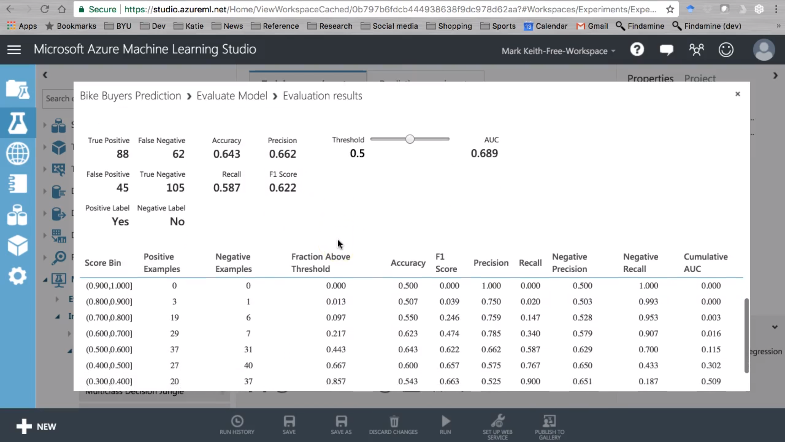

# **Two-Class Averaged Perceptron**

This classification algorithm is a supervised learning method, and requires a tagged dataset, which includes a label column. We can train the model by providing the model and the tagged dataset as an input to Train Model or Tune Model Hyper parameters. The trained model can then be used to predict values for the new input examples.

The averaged perceptron method is an early and very simple version of a neural network. In this approach, inputs are classified into several possible outputs based on a linear function, and then combined with a set of weights that are derived from the feature vector—hence the name "perceptron."

The simpler perceptron models are suited to learning linearly separable patterns, whereas neural networks (especially deep neural networks) can model more complex class boundaries. However, perceptron are faster, and because they process cases serially, perceptron can be used with continuous training.

**Model using Azure Machine Learning Studio:**

To demonstrate we are using an example of “Bike Buyers Prediction”.

**Dataset used:**

Input we are using:



**Dataset Snippet:**



**Experiment:**

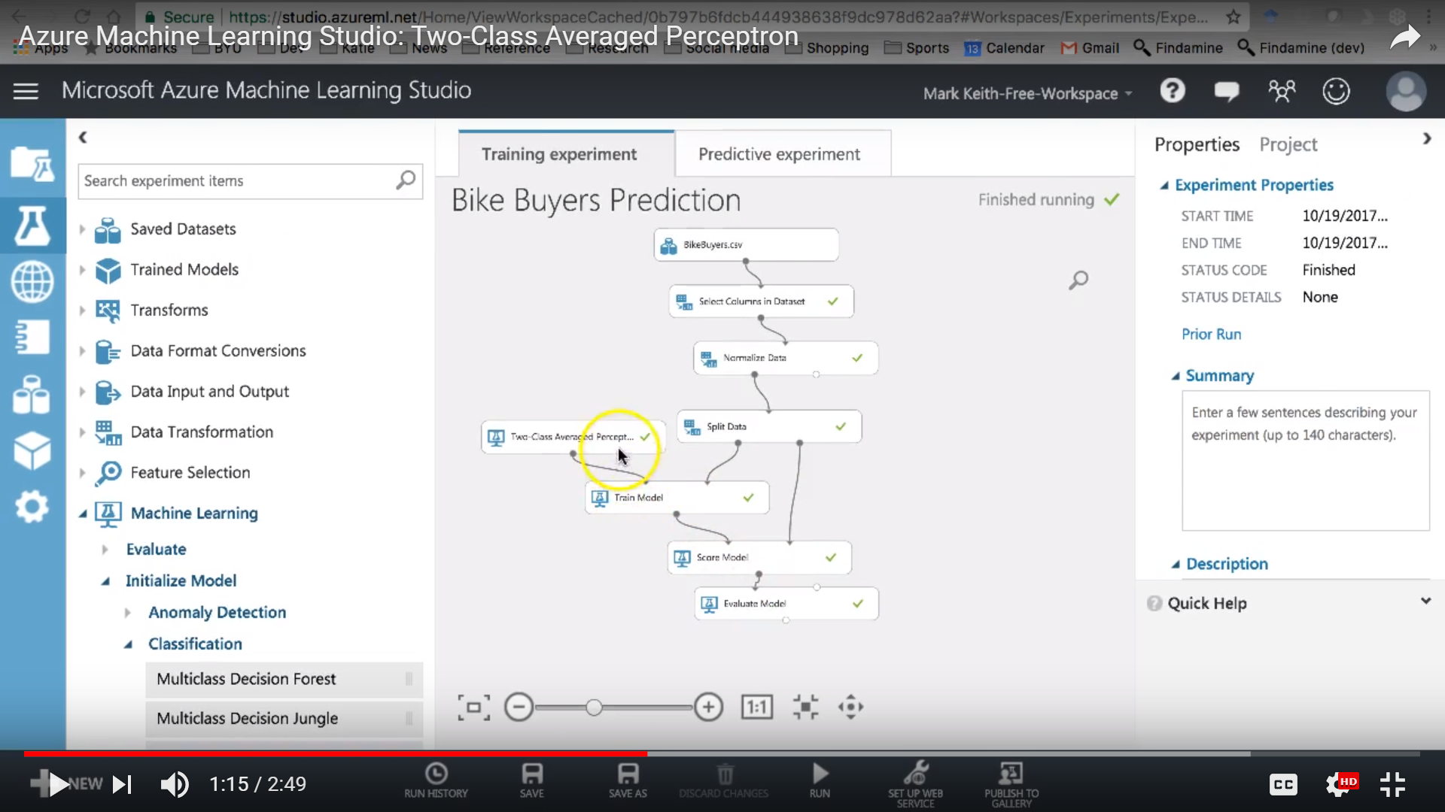

**Results:**

